U.S. Department of the Interior
Bureau of Land Management
Little Snake Field Office
455 Emerson St.
Craig, CO 81625
DETERMINATION OF NEPA ADEQUACY
Sand Wash Herd Management Area Permanent Trap Facilities
DOI-BLM-CO-N010-2023-0023-DNA

Identifying Information
Project Title: Construction of Permanent Bait/Water Trap Facility
Legal Description: T11N R98W Sec. 34
Applicant: Bureau of Land Management

Conformance with the Land Use Plan
The Proposed Action is subject to and is in conformance (43 CFR 1610.5) with the following land use plan:
Land Use Plan: Little Snake Record of Decision and Resource Management Plan (RMP) as amended by the Northwest Colorado Greater Sage-Grouse Approved Resource Management Plan Amendment
Date Approved: October 2011, amended September 2015.
Decision Language: LSFO RMP: Wild Horses/RMP-26 & 2.14 Livestock Grazing/RMP-41

The Proposed Action conforms to the RMP, as amended because it is specifically provided for in the following RMP goals, objectives, and management decisions:

Manage the Sand Wash Basin wild horse herd and its habitat to encourage herd health while
maintaining a thriving, natural, ecological balance of rangeland resources. Objectives for
achieving this goal include:
- Manage the Sand Wash wild horse herd as an integral part of the public lands ecosystem at an appropriate management level (AML). Periodically reevaluate the existing AML to ensure herd size remains compatible with other resources.
- Recognize and proactively respond to potential conflicts, as they occur, between the wild horse herd and other resources.
- Maintain herd management area (HMA) boundary fences to encourage wild horses to remain within an HMA. If horses relocate outside an HMA, attempt to herd horses back inside the HMA as expeditiously as possible

Section/Page: Northwest Colorado Greater Sage-Grouse Amendment, Wild Horses

Objective WHB-1: Manage wild horses in a manner designed to 1) avoid reductions in grass, forb, and shrub cover, and 2) avoid increasing unpalatable forbs and invasive plants such as Bromus tectorum.

Management Decisions (MD)

MD WHB-6: (PHMA) When conducting NEPA analysis for wild horse management activities,
water developments, or other rangeland improvements for wild horses in PHMA, address the
direct and indirect effects to GRSG populations and habitat. Implement any water developments
or rangeland improvements using the criteria identified for domestic livestock identified above in PHMA.

Proposed Action
Project Components and General Schedule
BLM LSFO proposes to construct permanent bait/water trap facilities within the Sand Wash Basin Herd Management Area (HMA). Construction of the first facility is proposed to begin no sooner than 6/1/2023 within existing disturbance at the Lake Draw well. The proposed facility would be approximately 130 feet long by 35 feet wide, or approximately 0.1 acre. Materials would include a combination of wooden and metal pipe for posts and metal pipe rails or prefabricated metal panels and gates attached to the posts, fence height would be six feet. The trap would include four gates for entry and exit of the watering location when not in use, when actively trapping, 3 of the gates would be closed with only one entry/exit point to the water. Figure 1 shows the proposed design of the trap facility.

Design Features
- When unattended, gates would be secured open to ensure no animals are unintentionally trapped. Trap site may be remotely monitored to ensure the safety of the horses.
Review of Existing NEPA Documents:
Name of Document: Little Snake Record of Decision and Resource Management Plan (RMP) as amended by the Northwest Colorado Greater Sage-Grouse Approved Resource Management Plan Amendment
Date Approved: September 2015
Name of Document: DOI-BLM-CO-N010-2018-0035-EA Modification and Expansion of Lake Draw Well (aka, Grainery Well) Livestock Water System
Date Approved: 7/5/2018
Name of Document: DOI-BLM-CO-N010-2016-0023-EA Sand Wash Basin Wild Horse Herd Management Area (HMA) Population Control
Date Approved: 9/21/2016
Name of Document: DOI-BLM-CO-N010-2021-0034-EA Sand Wash Basin Wild Horse Herd Management Area Gather
Date Approved: 8/17/2021

NEPA Adequacy Criteria
- Is the new Proposed Action a feature of, or essentially similar to, an alternative analyzed in the existing NEPA document? Is the project within the same analysis area, or if the project location is different, are the geographic and resource conditions sufficiently similar to those analyzed in the existing NEPA document? If there are differences, can you explain why they are not substantial?
Yes, the Proposed Action is similar in location and nature to what has been previously analyzed. The existing NEPA documents considered construction of range improvement infrastructure as well as capture and removal of wild horses using bait and trap method. The Proposed Action would adhere to the same Standard Operating Procedures (SOPs) and Comprehensive Animal Welfare Program for Wild Horse and Burro Gathers (CAWP) standards that were considered in the existing EAs.

- Is the range of alternatives analyzed in the existing NEPA document appropriate with respect to the new Proposed Action, given current environmental concerns, interests, and resource values?
Yes, the range of alternatives analyzed in the existing NEPA documents are appropriate for the new Proposed Action. The Sand Wash Basin Wild Horse Herd Management Area Gather EA analyzed three alternatives in detail. In addition, the Modification and Expansion of Lake Draw Well (aka, Grainery Well) Livestock Water System EA considered expansion of range improvement infrastructure at the proposed location as well as the no action alternative.

BLM reviewed existing environmental conditions, concerns, and resource values and identified no additional reasonable alternatives that would meet the purpose and need of the proposed action, were not substantially the same as existing alternatives, and were technically or economically feasible. The alternatives examined in the existing NEPA documents are adequate and valid for the Proposed Action.

- Is the existing analysis valid in light of any new information or circumstances (such as, rangeland health standard assessment, recent endangered species listings, updated lists of BLM-sensitive species)? Can you reasonably conclude that new information and new circumstances would not substantially change the analysis of the new Proposed Action?
Yes, the existing analysis remains valid. There is no new information or circumstance that would substantially alter the analysis of the Proposed Action. Existing NEPA documents considered construction at the proposed location as well as maintaining the wild horse population at AML within the Sand Wash Basin using various gather methods and administration of fertility control.

- Are the direct, indirect, and cumulative effects that would result from implementation of the new Proposed Action similar (both quantitatively and qualitatively) to those analyzed in the existing NEPA document?
Yes, the effects of implementing the Proposed Action are similar to those analyzed in the existing NEPA documents. Review by BLM LSFO specialists did not indicate there would be any direct, indirect, and cumulative effects from the Proposed Action that were not adequately addressed in the existing NEPA documents. The Proposed Action is the same as the previous EAs in that the analyzed bait and trap gather method would be used, and construction of a permanent facility is within the scope of the range improvement modification and expansion EA.

- Is the public involvement and interagency review associated with existing NEPA documents adequate for the current Proposed Action?
Yes. For the Sand Wash Basin Wild Horse Herd Management Area Gather EA, BLM LSFO reviewed comments received during external scoping of the DOI-BLM-CO-N010- 2016-0023-EA (September 2016) to identify issues previously raised by the public in regard to gather operations and fertility control plans over the next ten years within the HMA. This EA and the unsigned FONSI were available for public review and comment period beginning April 2, 2021 and ending May 2, 2021.

The Modification and Expansion of Lake Draw Well (aka, Grainery Well) Livestock Water System EA, BLM LSFO solicited public input during the planning process, no comments were received.

Interdisciplinary Review
The Proposed Action was presented to, and reviewed by, the Little Snake Field Office interdisciplinary team on January 16, 2023. A complete list of resource specialists who participated in this review is available upon request from the Little Snake Field Office. The table below lists resource specialists who were responsible for ensuring that the BLM fulfilled its consultation obligations under Section 7 of the Endangered Species Act and Section 106 of the National Historic Preservation Act.
Name | Title | Area of Responsibility | Date Signed
Eric Scherff | Hydrologist | Air Quality, Soil Resources, Surface and Ground Water Quality, Floodplains, Hydrology, Prime and Unique Farmlands, Wetlands and Riparian Zones | 2/10/2023
Whit Patterson | Recreation Planner | Recreation and Visual Resources, Lands with Wilderness Characteristics, Recreation, Access and Transportation, Scenic Byways | 4/25/2023
Valerie Baxter | Assistant Field Manager | Geology and Minerals | 04/25/23
Desa Ausmus | Wildlife Biologist | Special Status Animal Species, Migratory Birds, Aquatic and Terrestrial Wildlife | 2/9/2023
Taylor Prentice | Natural Resources Specialist (Plants) | Special Status Plant Species | 2/1/2023
Chris Rhyne | Rangeland Management Specialist | Invasive, Non-Native Species, | 1/18/2023
Tyrell Turner | Wild Horse Specialist | Wild Horses | 1/31/2023
Wendy Parker | Archaeologist | Cultural Resources, Native American Concerns, Paleontology | 1/30/2023
Brandon Voegtle | Fire Management Specialist | Fire Management | 2/1/2023
Tyrell Turner | Project Lead | Hazardous or Solid Wastes, Social and Economic Conditions, | 4/12/23
Janell Corey | Realty Specialist | Realty Authorizations, Socioeconomics, and Environmental Justice | 1/30/23
Hunter Seim | Assistant Field Manager | Livestock Grazing | 2/9/23
Gail Martinez | Planning & Environmental Coordinator | NEPA Compliance | 4/26/2023

Tribes, Individuals, Organizations, or Agencies Consulted
The NHPA requires federal agencies to consult with Native Americans regarding the effect of federal undertakings on areas or sites that may be of cultural or religious importance to Indian people to ensure that tribal values are considered to the extent feasible. In historic times, the LSFO field area was inhabited by the Utes and the Shoshone. Semi-annual face-to-face meetings between the BLM and the Ute tribes occur every Fall and Spring. An information packet on federal undertakings will be provided to Ute tribal representatives during the upcoming Fall meeting in April of 2023. The packet will include this proposed permit renewal, with an invitation to comment.
The Tribes who will be contacted with the information packet were:
• The Ute Indian Tribe of the Uintah and Ouray Reservation, Utah
• The Southern Ute Indian Tribe, Colorado
• The Ute Mountain Ute Indian Tribe, Colorado
Based on available information, areas or sites of Native American concern are not involved in the proposed federal undertaking. Areas known to be of concern to native peoples are not present at or near the undertaking, nor are sites of the kind that experience has shown to be of concern to Indian people located in or near the undertaking.
The Proposed Action would not have an adverse effect to Historic Properties as determined by two previous inventories overlapping the current APE conducted in 2014 (Collins 2014) and 2018 (Collins 2018). As such, this proposal does not require additional consultation with the State Historic Preservation Office (SHPO) pursuant to Section X.F.5 of the State Protocol Agreement between the Colorado State Director of the BLM and the Colorado SHPO.
The DNA was made available on ePlanning for a 30-day public review period and interested parties were notified.

References Cited
Collins, Gary
2014 Class III Cultural Resource Inventory of the Proposed Granary Well Pond Project, Bureau of Land Management Little Snake Field Office, Moffat County, Colorado. BLM-LSFO No. 10.3.2014. OAHP No. MF.LM.NR1307. Report prepared by the Bureau of Land Management, Little Snake Field Office, Craig, Colorado.
2018 Class III Cultural Resource Inventory of the Proposed Lake Draw Modification and Expansion Project, Moffat County, Colorado. BLM-LSFO No. 10.18.2018. OAHP No. MF.LM.NR1364. Report prepared by the Bureau of Land Management, Little Snake Field Office, Craig, Colorado.
U.S. Bureau of Land Management. 2011. Little Snake Field Office Resource Management Plan. October 2011. Little Snake Field Office, Craig, Colorado.
U.S. Bureau of Land Management. 2015. Northwest Colorado Greater Sage-grouse Resource Management Plan Amendment. September 2015. Northwest District Office, Grand Junction, Colorado.

Mitigation
- The BLM project lead is responsible for informing all persons who are associated with the project that they will be subject to prosecution for knowingly disturbing archaeological sites or for collecting artifacts.
- If any archaeological materials are discovered as a result of operations under this authorization, activity in the vicinity of the discovery will cease, and the BLM WRFO Archaeologist will be notified immediately. Work may not resume at that location until approved by the Authorized Officer (AO). The applicant will make every effort to protect the site from further impacts including looting, erosion, or other human or natural damage until BLM determines a treatment approach, and the treatment is completed. Unless previously determined in treatment plans or agreements, BLM will evaluate the cultural resources and, in consultation with the State Historic Preservation Office (SHPO), select the appropriate mitigation option within 48 hours of the discovery. The applicant, under guidance of the BLM, will implement the mitigation in a timely manner. The process will be fully documented in reports, site forms, maps, drawings, and photographs. The BLM will forward documentation to the SHPO for review and concurrence.
- Pursuant to 43 CFR 10.4(g), the applicant must notify the AO, by telephone and written confirmation, immediately upon the discovery of human remains, funerary items, sacred objects, or objects of cultural patrimony. Further, pursuant to 43 CFR 10.4(c) and (d), the operator must stop activities in the vicinity of the discovery and protect it for 30 days or until notified to proceed by the AO.
- The applicant is responsible for informing all persons who are associated with the project operations that they will be subject to prosecution for disturbing or collecting vertebrate or other scientifically important fossils, collecting large amounts of petrified wood (over 25lbs./day, up to 250lbs./year), or collecting fossils for commercial purposes on public lands.
- If any paleontological resources are discovered as a result of operations under this authorization, the applicant or any of his agents must stop work immediately at that site, immediately contact the BLM Paleontology Coordinator, and make every effort to protect the site from further impacts, including looting, erosion, or other human or natural damage. Work may not resume at that location until approved by the AO. The BLM or designated paleontologist will evaluate the discovery and take action to protect or remove the resource within 10 working days. Within 10 days, the operator will be allowed to continue construction through the site or will be given the choice of either (a) following the Paleontology Coordinator’s instructions for stabilizing the fossil resource in place and avoiding further disturbance to the fossil resource, or (b) following the Paleontology Coordinator’s instructions for mitigating impacts to the fossil resource prior to continuing construction through the project area.

Mitigation Carried Forward From DOI-BLM-CO-N010-2021-0034-EA
- During gathering operations safety precautions would be taken to protect all personnel, animals, and property involved in the process from injury or damage, consistent with BLM’s CAWP (Appendix B and BLM PIM-2021-002). Only authorized personnel would be allowed on site during the removal operations. Included in the “gathering and removal” operations 13 would be sorting individual wild horses as to their age, sex, temperament and/or physical condition, and to return selected wild horses back to the HMA.
- Contractors and/or BLM personnel would utilize trailers to transport gathered wild horses to a temporary holding facility where they would receive appropriate food and water. Holding facilities and gather sites have historically been located on both public and private lands due to road access and availability of water.
- Wild horses that are removed from the area would most likely be transported to BLM’s Canon City, Colorado holding facility where they would be prepared (freeze-marked, vaccinated, microchipped, and de-wormed) for adoption, sale (as regulations permit), or off-range pastures unless unforeseen circumstances warranted that the wild horses be transported to a different approved BLM holding facility (i.e., at Rock Springs, Wyoming).
- During gather operations, the Contracting Officer Representative (COR), as delegated by the AO prior to the gather, would authorize the release or euthanasia of any wild horse that they believe would not tolerate the handling stress associated with transportation, adoption preparation, or holding. No wild horse should be released or shipped to a preparation or other facility with a preexisting condition that requires immediate euthanasia as an act of mercy. The Incident Commander (IC) or COR should, as an act of mercy and after consultation with the on-site veterinarian, euthanize any animal that meets any of the conditions described in IM 2015-070.

Appendix A. Figures
Figure 1. Proposed Trap Design
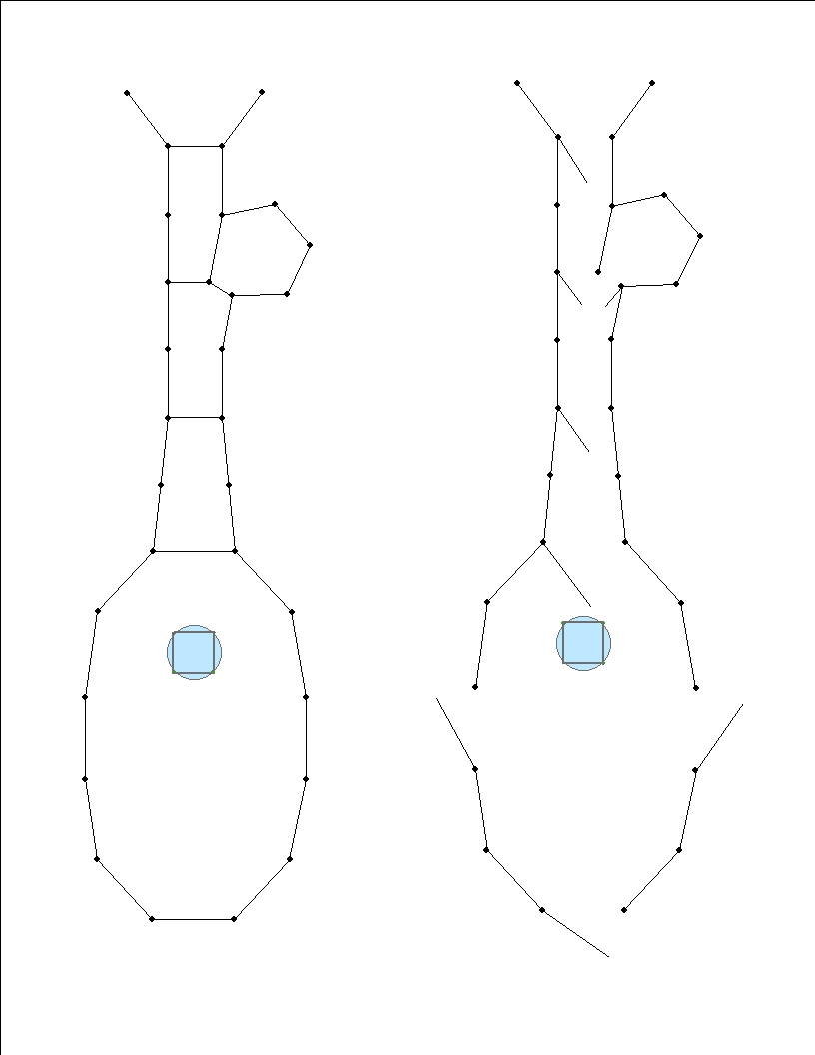
Map 1. Lake Draw Facility Location
