07/09/21

BLM AK
Comment on NEPA Number: DOI-BLM-AK-A020-2020-0037-RMP-EA
Project Name: East Alaska RMP Amendment Draft EA
Alternative 1, No Action Alternative Vote

Team BLM AK (including but not limited to Marnie Graham, Serena Sweet and Erika Reed),

While l have lived in Thompson Pass for over 3 decades, I have also spent considerable time in dozens of villages as well as in Alaska’s deep backcountry. I love all of Alaska, but I have had a natural affinity with Thompson Pass since its magnetism kept me from leaving a snow cave colony, over 30 years ago. My friends headed back to the other side of the Chugach and I did not. I stayed in a cave on the land being considered for exchange from public ownership to a private corporation. I still live in the same neighborhood. I grow and harvest the majority of my food from my land, nearby land and the water; a dream that a third generation born in Detroit girl could not have known to imagine. My gratitude and love for Thompson Pass is unwavering.
And this love provides the foundation for my comments; there is no commercial interest or personal monetary profit enmeshed in my words.
During the 2 public meetings on 6/17/21, I was the only member of the public who was not a Chugach Board member to speak (likely due to BLM’s failure to notice interested parties). I represent both Thompson Pass, because it does not speak your language, and anyone (non-Chugach Corporation shareholder) that has ever experienced its awe. I am a strong woman whose tears met the air when reading the Draft Amendment. Tears for the air, the land, the flora and the fauna. Tears not only for the countless native (but not Chugach Corporation shareholders) and non-native folks who recreate on the land, but also for the 300+(DOT) daily cars that actually represent the greatest number of folks who are intoxicated/inspired by arguably one of the worlds most spectacular road accessible viewsheds. “Pristine!” is the word I hear over and over again. Folks from across the globe, many who make an annual pilgrimage, flock to the beauty. It’s where ashes of loved ones are spread, it’s where trauma has been mended, it’s where families make memories. It’s where, even in the dense fog that was clinging to the mountain, I helped a drug dealer find the self he had lost; he’s been healthy and sober for years. This land feeds spirits, guides, operators and the local economy. And mostly importantly it nourishes the physical and mental health of both Alaskans and tourists alike. This land is the renewable asset capable of sustaining the physical/emotional and economic health of Valdez, a crucial scoping comment point missed by the amendment.
BLM’s amendment also failed to address many other comment concerns. Energy security and national security were ignored. At the very least, the refinery, the fuel trucking companies and the military should have been invited to the conversation to comment on the potential clogging of their critical artery.
When I first got wind of the proposal for an amendment that could make the Thompson Pass hairpin land sections available for exchange, Glennallen’s Field manager stated “If the people, the public who owns this land, say ‘Not this land’, then we will have to look at different land.” And when word got out, in a matter days, mostly between Christmas Eve and the day after New Year’s,143 folks (one representing 6,000 voices, another 10,000 and another 160,000) overwhelmingly said, “Not this land!”. Hunters, defenders of wildlife, motorheads and self-propelled recreationalist all stood on the same ground. But the Finding of No Significant Impact, FONSI, indicates that their comments were not heard.
This failure to comply with public process poses an issue. BLM is authorized to conduct land exchanges under the Federal Land Policy and Management Act (FLPMA) of 1976. FLPMA governs how administrative exchanges are to occur “where the Secretary concerned determines that the public interest will be well served by making that exchange”, Public Law 94–579—Oct. 21, 1976, as amended through May 7, 2001, pg.11) Herein lies the chorus of my comment, land exchanges must be in the public interest (43 B.SC. §1716(a)), just ask FLMPA.
“The Federal Land Policy and Management Act is central to everything we do at the Bureau of Land Management. All of the actions we take rely on the authorities that were built into this law by Congress and the President. We use FLPMA every day to guide our management.” -blm.gov Why would BLM trade land? “enhancement of recreational opportunities and public access” (Congressional Research Service Report, CRSR). FAILED! “In making an exchange, BLM is to reserve any rights or interests that are needed to protect the public interest, and may impose restrictions on the use of lands conveyed. BLM is to consider only proposals that conform with land use plans” (CRSR). DOUBLE FAILED! And FLPMA require(s) that exchanges of land or interests therein be for equal value. FAILED! (Public Law 94–579—Oct. 21, 1976, as amended through May 7, 2001, pg.13) Like a mantra, these FLPMA references will be revisited.
Now, 6 months later, the public has been invited to comment on the Draft Amendment, DA, which has no premises to even exist. And which, with all due respect to its creators from afar, is littered with falsities and reads like a fill-in-the blank form letter. Particularly preposterous and repeated countless times is the first line of the draft’s 2-part chorus, “It is assumed that future development that could occur if lands are exchanged would be low intensity and in line with the limited infrastructure and development in the Thompson Pass region.” BLM has confirmed the fact that if a land exchange were to occur, the Chugach Corporation would then have surface and subsurface rights and would be free to do literally anything they wanted with the land. Nonetheless the second part of BLM’s DA chorus for most concludes, “Therefore this issue was not considered in detail and has been eliminated from further analysis.” Wow!
BLM’s chorus seems ludicrous knowing that in January I sent them this 9/26/20 Mining News North article (ADDENDUM: Mining News North) about Chugach Alaska Corporation, CAC: https://www.miningnewsnorth.com/story/2019/12/01/in-depth/purpose-tradition-guide-chugach-alaska/6080.html Some article highlights: “Chugach has begun to investigate the mineral potential in areas of historical mining on lands it owns in the region.” BLM knows that there used to be a mining claim at the Thompson Pass hairpin turn as well as along the Lowe River. The article emphasizes “ . . . ensuring economic opportunities for the people of the region”. And explains that even though they only had subsurface rights in Prince William Sound’s Port Gravina, the corporation still managed to find a way to commence a new mining operation, "Though it was quite an effort, in the end, we were able to assert our rights as the owner of the dominant subsurface estate and our granite products will be on the market soon," Hickel said. The article continues, “Beyond mining granite that can be used for coastal infrastructure projects along Alaska's massive coastline, Chugach Alaska has recently resumed exploration of the other mineral resources known to exist on its lands.” And it notes that Chugach Corporation has been doing exploration for “metallic minerals” and details 5 specific Chugach Region sites where they have been proactive. “In addition, Chugach Alaska subsidiaries are ready to support development within the region. Chugach Alaska Services, an Alaska Native focused staffing service, is particularly well suited for supporting mineral exploration in the region and across the state.”
The entire amendment is non-sensibly based on the corporation’s presumed low-impact. Meanwhile the corporations worldwide imprint is massive. According to Bloomberg and confirmed on their site, “Chugach Alaska Corporation provides diversified business services. The Company offers base operations, facilities maintenance, general construction and management, information technology, telecommunications, and employment services.” Examples of Department of Defense contracts include $30.8M+, $28M+, $13.6M+, $8.8M+ etc. . . . not to mention real estate holdings and many other companies and investments. There is absolutely nothing “low-impact” about CAC (except perhaps for their investment in the mental health of their shareholders, in the past month alone, within about 40 miles of their region, there has been, at minimum, an overdose death, a death by alcohol and a death by suicide). When I first got word of Chugach’s proposal, I contacted David Phillips and volunteered to help develop a mental health program with an emphasis on getting folks reconnected to the land. He emphasized “economic viability”. I emphasized health and longevity.
Now let me reiterate BLM’s chorus that has been repeated countless times in the Draft Amendment, “It is assumed that future development that could occur if lands are exchanged would be low intensity and in line with the limited infrastructure and development in the Thompson Pass region.” There was no “infrastructure before Red Dog (or any other) Mine was developed. Infrastructure comes with big development. Presuming that impact will be low due to lack of infrastructure is ludicrous. BLM brushes off owning any responsibility, repeating this line they release themselves one item at a time, from the air, water, soil, flora, fauna, flooding, wilderness value and history. Repeating a lie does not bring truth. And each time this statement arises, its captions are closed with the following equally absurd conclusion/chorus, “ . . . this issue was not considered in detail and has been eliminated from further analysis.” “This issue” is referring to the air, water, soil etc. I am asking BLM, as I did during public comment, to remove each of these sentences. They are a blatantly unrealistic cope out. The public deserves each and every one of these items to be taken into consideration, not to be written off with false presumptions.
I’d like to remind BLM that, in truth, we should not even be in this “amendment” discussion, it’s concept, like its content is based on this same insidious theme - false presumptions. Apparently my “All Systems Stop!” request was (silently) denied. Section 113.2.a of the Dingell act requires a study to “assess the social and economic impacts of the program”. The corporation entered (EVOSTC) “the program” willingly and received far above Fair Market Value compensation. The study that was required to be completed nearly a year and a half ago still has not been completed. After the study in “a” is complete, Section 113.2.b and c ask for acreage to be identified and recommendations made for land exchange options. Plural denotes a quantity greater than one. “b” and “c” are contingent on the results of “a” warranting an exchange. And since the corporation entered an agreement to willingly profit, the “study” should prove that there is no merit for an exchange. BLM has erroneously stated that the Dingell Act “requires” this amendment. This amendment is based on false pretense. There are 2 lines from the AK Wilderness League director, Andy Moderow’s, public comment that resonate, “BLM should conduct the study and offer recommendations based on the language that exists today in the EARMP.” And “At its core, though, the process is flawed because it relies on a mis-reading of the Dingell Act.”
And to add to the confusion, no one at BLM has yet been able to explain to me why BLM published in the Federal Registrar on 11/24/20 that the land would be offered in “exchange for those lands acquired through EVOSTC”. The words of the act are amazingly concise and yet BLM, again, has drawn conclusions with no evidence to merit.
Hilary Eisen Policy Director for Winter Wildlands and Louis Geltman Policy Director for Outdoor Alliance concur with both Moderow and Wax, “. . . the Dingell Act does not require the BLM to perform or prepare a land exchange, or to even amend the RMP. Rather, the Dingell Act requires the BLM to conduct a study of land ownership and use patterns in Alaska’s Chugach Region and report the results of this study back to Congress. Nothing in the Dingell Act requires BLM to amend the RMP at this time, much less to prepare a land exchange. Therefore this NOI rests on a faulty premises and must be revised. This NOI should read that the BLM intends to conduct a study of land ownership and use patterns in Alaska’s Chugach Region, and this should be the focus of the EA.” Again, the “study” has not been completed.

Defenders of Wildlife attorney Patrick Lavin puts succinct verbiage to what BLM has misconstrued, “In short, BLM has apparently failed to publish the study that the Dingell Act directed it to publish. Claiming to implement the Dingell Act, it has instead proposed an RMP amendment that the Act did not direct, to facilitate the exchange of specific parcels that are currently not available for exchange. Because there is no study, there is no basis to conclude that any land exchange with CAC is appropriate, and even if it were appropriate, there is no assessment of potentially available land to inform the choice of specific parcels. There is also no hint of what lands may transfer to public ownership and thus no way to begin to evaluate the benefit of the bargain.”
BLM was not able to inform me of what lands the corporation intended to offer for exchange. But after hundreds of hours of research I was able to find the land offering – remote very steep, partially glaciated north facing land on top of an absolutely inaccessible mountain in the Wrangell’s (Attachment: DNR Research, p.36). A boat or plane would be of no use. And there is no “hairpin” turn or any road at all. Remember FLPMA require(s) that exchanges of land or interests therein be for equal value. (Public Law 94–579—Oct. 21, 1976, as amended through May 7, 2001, pg.13). And don’t forget my chorus, “land exchanges must be in the public interest”. (43 U.S.C. §1716(a)) The jets don’t even fly this route, so truly no one would ever get to enjoy this land, not even from 30,00 feet.
And truly there is no land in all the world of equal value. I snapped this pic near the end of May from on top of a run known to skiers as “Berlin Wall”. And remember, it is only capturing one, south-facing, aspect. There is so much more! There are countless ski runs in this frame. Would you travel to Alaska from Italy to ski in the viewshed of a mine? While the focus of comments has been on the actual land acreage at stake, I am asking Marnie, Serena, Erica and the rest of the BLM folks to zoom out for a moment. Look at this photo and get some perspective. Something enormously grander than this land is at stake. Something unique in all the world:
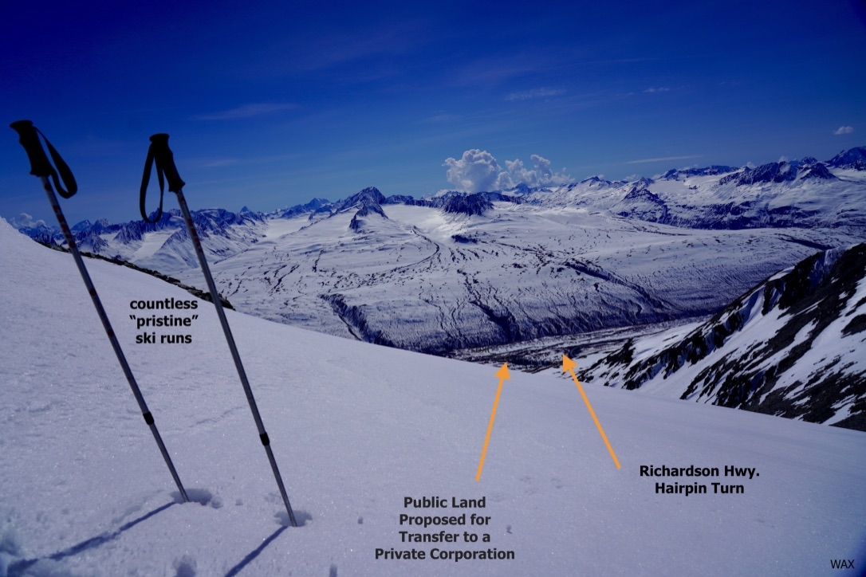

The Act specifies “provide recommendations for land exchange options”. Where are the other “options”? Additionally, the Dingell Act does not define “accessible” as “highway accessible”. Alaska is barely road accessible but has over 46,000 miles of tidal shoreline. There are approximately 2 million acres (no one at BLM knows the number) of BLM managed land in the Chugach Region, much of it is close to water or on the water. But no other options, plural as stated in the Act, are being explored. Why? Because of politics. Senator Murkowski, who depends on the native vote, sponsored the Dingell Act which Trump signed. And then the Chugach Corporation went to another politically appointed official, Corey Feige, the Commissioner of DNR, who then pressured the DNR staff to conditionally relinquish its’ State selected land (specifically contingent on the Chugach Corporation transfer). The DNR staff were taken by surprise. From: Stolpe, Adrienne K (DNR) on 12/7/20
Sent: Monday, December 7, 2020 To: Pinckney, Charles A (DNR) ,Hamner, Lacy C (DNR)
Subject: RE: East AK RMP Amendment “As far as I am aware, we have no plans of relinquishing any selections in the area.” Same day, Chuck replies, “really just need to know if we had promised anything to them regarding our selections.” Same day, Adrienne replies, “As far as I’m aware, absolutely not. We’ve received pressure to relinquish lands for years and always push back. Unless something was promised higher up, which I doubt, I’d operate under no promise to relinquish.” (Attachment DNR Research, p.77). Next communication in the file was from politically appointed Commissioner Feige pushing forward the land exchange in a 1/27/20 letter addressed to DNR’s Deputy Commissioner and to both the Director and Deputy Director of the Division of Mining, Land and Water. The letter included an attached draft land exchange contract prepared by the corporation and Commissioner Feige stated, “Please look at the parcel and determine what would need to be done to lift the state selection . . . Thank you very much for your work on this”. (Attachment: DNR Research p.28).
The DNR research attachment also provides a RUDE wake-up call to the catastrophic precedent setting potential BLM has in its hands. Page 8 explains that, while in a hairpin land exchange meeting, Martin Parsons, the Director of DNR’s Mining Land and Water, suggested entertaining other exchanges like “the bathtub ring” around Prince William Sound. Wow! The precedential power here is ginormous.
“BLM is to consider only proposals that conform with land use plans” (CRSR). Nothing here about amending land use plans to make them conform. BLM has not only disregarded multiple FLPMA laws but it is also defying this land’s Federal guiding doctrine, BLM’s East Alaska Resource Management Plan, which clearly states that these land sections are not available. What is the point of establishing law if BLM is going to obediently jump to amend it on a private corporation’s whim? It was irresponsible of the state to conditionally relinquish the land without public input. DNR’s DMLW is absolutely the front door enabler. DNR has set up BLM. And now BLM has to awkwardly find its way out of a precarious situation. BLM has the opportunity to serve the public that DNR has failed.
And BLM has established that giving the land to a private corporation is against its’ guiding doctrine, the EARMP. If BLM plans on amending policies every time a private corporation reaches out, what is the point of policies and why should the public have any confidence in the institution?
And, again contrary to FLPMA, a land exchange is not only against the federal guiding doctrine, EARMP, but it is also against the State’s guiding doctrine (not so incidentally, 1.8 Relationship to Statutes, Regulations, Other NEPA Documents designates both EARMP and CRBAP as “key” “plans”). The Copper River Basin Area Plan, CRBAP, clearly states, “The management unit (Unit 15: Thompson Pass) should be retained in state ownership . . . with an emphasis on expanding recreation opportunities (3-103)”. Thompson Pass was one of three areas “recommended for legislative designation (for) hav(ing)e very high recreation value and receiv(ing)e the most public use (A-5).” “The potential for conflict between minerals and other resources is high in these areas. The relative values of fish habitat or recreation are higher than potential mineral values and therefore warrant a closure (A- 4).” “Due to land conveyances under the ANSCA and state land disposals, the primary trail issue is to retain and designate existing access to state land (A-6).” There are paper trails going nearly all the way back to Statehood pushing for this area to become a State Park. The State even funded a 100-page study decades ago to get the momentum going. The public and the state have been trying to transfer this land into a legislatively designated State Park for several decades. But the idea evaporates each time the funding does not materialize. State Park or Private Corporation (with a potential mine, nuclear plant or who knows what)? Spin the Wheel of Fortune! The public or the corporation?
Privatization of this area has always been against Public (the landowner’s) opinion. The public and the (now “abandoned” by the State) Citizen’s Advisory Board has, for many years, unanimously opposed commercial development in Thompson Pass. Example - On 10/1/04 the Citizens Advisory Board (chosen by the Director of the Division of Parks and Recreation to ensure that a broad spectrum of public interest would be represented), sent a (yet another) letter to the DNR stating “For the better part of the last decade the Citizens Advisory Board has had numerous instances to hear public comment about development in the Thompson Pass area. The board can state unequivocally that the overwhelming majority of public comments have been against permanent year-round commercial development of the Thompson Pass area.”
Now that I have substantiated that I should not be commenting on this Draft Amendment because it should not exist, I will reluctantly proceed with comments. I was unable to get answers to many of my questions until the day before the original deadline day. Even the Public Information Office was instructed to not respond to my calls. It’s exponentially more difficult to respond to something that should not exist when you can’t get the facts from the source and, to top it off, your concerns from the last round were dismissed.

1-1.51 have been addressed above.

1.5.2 I have already requested, on the basis of being forthright about reality, that BLM eliminate both sentences of their (previously defined) chorus from the entire DA. It is criminal for BLM to dismiss concern for the “Lands, Water, Fisheries, Visual Resource, Paleontological Resources, Subsistence Use, Wildlife Management, Forest and Vegetation Management, Soils, Public Health and Safety, Mineral Resources and Environmental Justice” based on blatant falsities. I will highlight some examples.

Land. The DA states that the “lands are managed under the State of Alaska Generally Allowed Uses”. Wrong, Thompson Pass is exempt from DNR’s 11 AAC 96.025.

According to the DA, the land is not “formally determined to have wilderness or potential wilderness value”. I took this photo last January while a friend was facetiming the “hairpin” view to cheer up his Co-vid infected brother. The fact that it is shrouded in clouds only seems to amplify its “wilderness value” or lack thereof according to BLM. You decide:
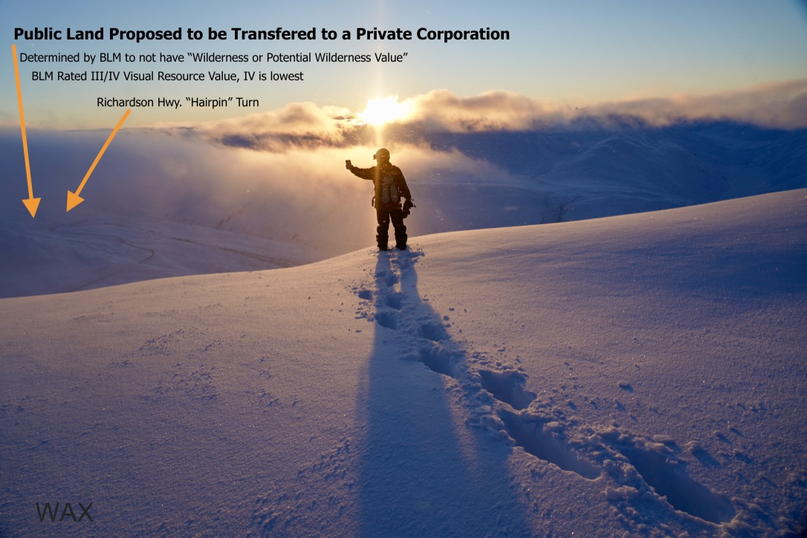

Water. Please reread the FEIS. In your words, “The FEIS concluded that development could have a negative impact on water quality”. And a few lines below you state “ . . . this plan does not put forward management alternatives that would have a measurable impact on water resources.” This disconcerting style of stating opposites in the same paragraph is a recurring theme throughout the DA. BLM please comb through the document, choose your side, and delete its contradiction.

Fisheries. The salmon creek is 7 miles, not “10 miles”, downstream. Not only were the 3 closest lakes, that are stocked, overlooked but the DA also forgot to acknowledge that the water, the Lowe River, running through these selections feed into Prince William Sound. And the Sound feeds subsistence, sport and commercial (Alaska’s largest private sector employer) fisheries. The commercial salmon fishery alone brings in 4.2 million pounds . . . feeding the local economy. BLM, please add the hatchery, the United Fisherman of Alaska and RCAC to your next comment notification list before assuming your chorus, once again, “no further analysis is necessary”.

Visual Resources. As demonstrated by the last photo, the visual magic is ethereal, even when obstructed by clouds. Yet BLM has degraded these land selections to its 2nd lowest Visual Resource rating, III/IV. BLM please revisit this conclusion!

Paleontological. To claim something is not there when you have not looked is not “logical”.

Subsistence. How could a mine not “have a measurable effect on subsistence uses”?

Wildlife Management. How could a mine not “have a measurable effect on wildlife resources”? I beg BLM to break out of the form letter, out of the office, walk the land. I would be delighted to hike or ski in with you. Trumpeter, not tundra, swans were reported in the initial comment. Assuming that they will use other water bodies highlights that BLM does not realize they return to the same pond/lake every year. And the other nearby water bodies are on the highway system. Imagine moving from your AK acreage to a Staten Island apartment. And there are Threatened species in the planning area. There are a massive number of bumblebees which are on the sensitive invertebrate list. Watchlist animals include golden eagles, trumpeter swans, Alaskan hares and arctic ground squirrels. And there could be more . . . please do your due diligence.

Forest and Vegetation Management. Sensitive plant species which appear to be on the land include long leaf arnica, arctic poppy (the bumblebee’s favorite hangout, their fit in the petals provides optimal heat absorption) and pacific buttercup.

Public Health and Safety. I was let down to see my avalanche concern, a critical human safety issue that I submitted to BLM, left out of the DA. My concern is two-fold, the impact of both live drilling/blasting while unassuming climbers or skiers are recreating out of site on the north side (or even on the south side) and the consequence of an accumulated weakened structural integrity from construction (or who knows what). This photo/ski map, which I have already provided to BLM, illustrates that there are countless easily accessible and regularly accessed ski runs (Odyssey, Schoolbus, Goodwills, Little Matterhorn, Gulley 1 & 2, Berlin Wall, Nick’s etc.) also on the back side of the selected lands. Not only can the north faces (viewed in the photo) of any of these runs be skied, but the south faces, which run down to the land sections can also be skied. And sometimes, until you get to the top to assess the conditions, you do not know which way you will descend. Folks usually bail for the mellower south option when there is a question about stability or when they decide they are seeking a less technical run. The picture shows that most of this land is actually a part of one larger mountain (which receives the greatest concentration of recreation in the Thompson Pass corridor). In fact the north side of "Schoolbus" (named because it once buried a school bus on the highway), which drops down into the land sections on its back/south side, slid naturally across the highway the same day of the Valdez City Council meeting this last January when BLM’s Marnie Graham and Erika Reed participated telephonically. I had to wait on avalanche blasting at Snowslide Gulch to get to the meeting. Avalanches happen and have killed people in areas appearing on this photo/map. BLM needs to address avalanche safety. I am asking BLM again to zoom out, to widen your perspective when looking at the photo (not sure who to credit), it is all connected:
Use the “hairpin” turn in maroon in the lower middle section to orient.
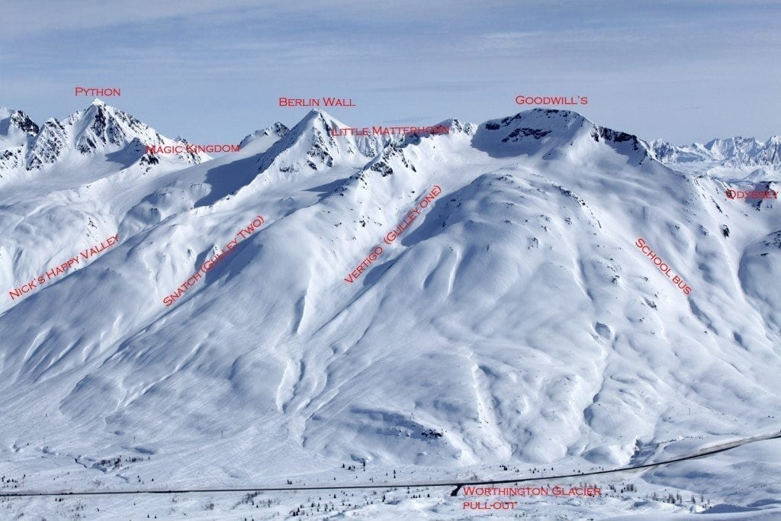
This below photo is showing the connectivity of all the runs from above picture, in addition to showing farther lookers right to include the north/nw side of Odyssey: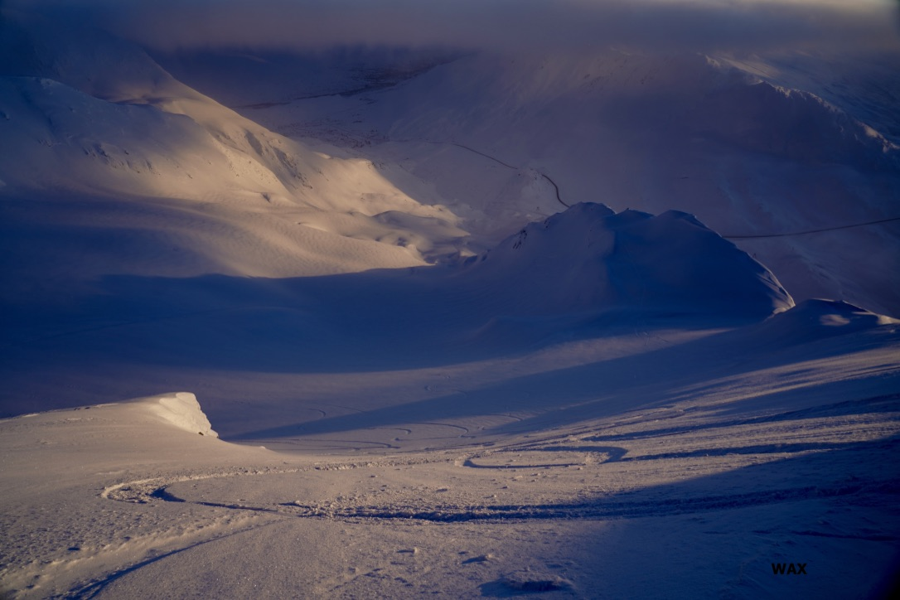

Blasting etc. could also affect the nearby Alyeska Pipeline. The section nearest to these land selections is the steepest portion of its’ 800 miles. And there is currently an unresolved maintenance issue. The 30’ investigative dig was recently postponed. There has also been historical shaking/vibrating issues that have caused structural damage to homes in the Heiden View neighborhood. BLM should explore whether there are mines in such close proximity to the pipeline anywhere else. Sure sounds like a match made of fire and gasoline! BLM should have invited Alyeska to comment. Please include Alyeska’s Peter Nagel in the conversation as you proceed.

Flood hazard was also left out of consideration. About three miles after the Lowe River leaves the land sections, it runs near the lower Heiden View subdivision road where there has been historical issues with flooding. Additionally, there could be issues with particulates or toxic dust from the hairpin land which is approximately 2000’ above the subdivision that is located on the floor of the valley (where heavy particles could get trapped below weather systems). But BLM repeats the chorus, “Effects on public health and safety were not considered in further detail and have been eliminated from further analysis.” Manufacturing cigarettes does not cause cancer. At the very least, BLM must take responsibility as the enabler. And demonstrate courtesy by contacting the approximately 17 home owners thereby giving them a chance to be a part of the discussion.

Mineral Resources. I applaud BLM for acknowledging that both “the mineral resources could be developed” and that “gold has been historically mined in the Lowe River.” Though it did not make the DA, BLM’s Glennallen field manager did also inform me that there was a historic mining claim at the hairpin turn. And then BLM repeats the chorus, “It is assumed that future development that could occur if lands are exchanged would be low intensity and in line with the limited infrastructure and development in the Thompson Pass region . . . this issue was not considered in detail and has been eliminated from further analysis.” BLM, please face the music of your chorus. And see if it resonates.

1.6 Planning Criteria. “The RMP Amendment/EA will consider a reasonable range of alternatives.” BLM, What are the “range of alternatives”? Sure appears that Thompson Pass was the only alternative considered.

Please review Secretarial Order 3373 “which requires documentation of impacts to recreational access”. For example, 3.3 reads “without data on use patterns . . . it is not possible to say . . .”. Why has BLM not reached out to any of the outdoor operators in an attempt to gather data and to invite them into the conversation?

1.7 Planning Process. BLM’s refusal to remedy the public notification goat rodeo has been disheartening, a genuine disservice to the public.

The public who had originally commented and requested updates (by checking a BLM provided box) had every right to believe they were going to be kept in the loop, but BLM dropped the ball. I gave BLM names of folks who expected to be contacted and were not contacted. Not until after my 5th inquiry did BLM phone me, on Friday afternoon 7/2/21, to inform me that I was correct. "Must have been a computer glitch", admitting that at least "85" of those folks were left out of both the 30-day comment period and the public meetings. BLM did then email notice the 85 forgotten folks (on Friday afternoon), on what was supposed to be deadline day.

BLM attempted to remedy the situation by granting an extension until the following Friday, 7/9/21. So, these newly informed folks were (almost) given 4 business days to review and comment on 40 pages of material after summer's busiest holiday weekend. And then in the process of updating the extension on line, BLM deleted the "Participate Now" button so that no one could comment (Friday, Saturday, Sunday & Monday) until BLM got my email to remedy the situation on Tuesday 7/6/21 (and they did). I repeat, for about a week, in the final days of public comment . . . there was no way of submitting a public comment. So now these newly informed 85 folks, who were not invited to participate in the public meeting, have been given 3 business days to review and comment on 40 pages of material. So not only were these folks denied a reasonable public process due to a BLM error, but I also notified BLM a week ago that there are additional folks who have still not been contacted. No reply from BLM thus far. And I just spoke to someone who said he chose to be contacted through the mail. He was upset to be left out. Why, he wondered, were both snail mail and email options offered during the scoping if BLM was only going to follow-through via email? Great, albeit unfortunate, question. At the very least, the 85 folks should be granted a 30 day, not a 3-day, comment period. Request denied.

BLM has failed to abide by its “Planning Process”. “Release of this Draft RMP Amendment/EA and an unsigned draft FONSI will initiate a 30-day public comment period during which the BLM will host a virtual public meeting.” There was certainly no confusion about the Chugach Corporation shareholders being notified of the public meetings. They got on the guest list without even submitting a scoping comment while many other folks of the public who signed up for email updates during the scoping comment period were left out of the loop. The public should not have to bear the burden, should not be silenced and removed from transparency on account of “technological glitches” (or political pressure).
According to BLM’s planning site, “Nine different Alaska Native Tribes and Corporations received formal invitations for consultation twice, in November of last year and this June. 13 additional emails were sent to tribes and corporations about the meetings.” The same page claims BLM “conducted outreach . . . through their email lists”.
In regards to deadlines, the federal registrar site reads, "In general, agencies will specify a comment period ranging from 30 to 60 days in the “Dates” section of the Federal Register document, but the time period can vary. For complex rulemakings, agencies may provide for longer time periods, such as 180 days or more. Agencies may also use shorter comment periods when that can be justified.” BLM, I am struggling to understand any justification for a 3-day deadline to review 40 pages after summer’s biggest holiday. The proposed exchange has now crashed winter and summer’s biggest holiday. Is it more than mere coincidence?

And as if the defunct notification had not clouded the, everything but fair, process enough, I had notified BLM that it was laborious for an average luddite to locate the original "Participate Now" button. Not only did it require navigation through multiple screens (a friend with a master’s degree could not figure it out). But then you had to know which fine print to read to know which document, in a long list, to locate. And then, on my screen, I had to scroll over to reveal the "Participate Now". Everything but the most important button appeared on my screen.

On 7/6/21, the conundrum got deeper again. Just before the 7/9/21 deadline a less laborious to locate "Participate Now” button metamorphosed . . . but suspiciously only Alternative 2 and Alternative 3 Maps appeared above the button and Alternative 1, the No Action Map option had no presence. (On the basis of the power of suggestion) I did request BLM remedy this situation. It has not been remedied. Minutia, perhaps, in relation to the other idiosyncrasies . . . but it all takes a toll on the public. It is nice that BLM made the “Participate” link more visible in the last few days and nice that they were trying to provide map options. I do believe that BLM cares (and that they are short-staffed and over-worked). But it would have been significantly nicer to have included a big picture map that was zoomed out more and showed the attached 2 sq. miles of the already native Tatitlek owned land toward the Tasnuna as well the attached 22 sq. miles toward the Deserted. I would have suggested this had the maps not appeared at the last minute. One map could have sufficed to illustrate all options and the bigger picture.

Melinda, the 2/17/21 public meeting moderator, stated that the Q&A (which was disabled early so folks could not see the answers) and the audio (which was, in part, garbled) of public comments would be posted to the eplanning site as soon as possible. Two weeks later, it still has not been posted. I have made requests. Marnie indicated that there were "technical glitches" with their contracted company. These are tools that could have been used for preparing DA comments and informing the folks who were not available to participate. Because I was not able to keep up with the Q & A answers from the first meeting (it was disabled “to move on” while I was typing questions), I decided to ask my questions during the public comment portion of the second meeting. And then the moderator informed me that questions would not be answered during the meeting. I had switched up formats because the one question that got asked at the 1st meeting was promptly answered. Melinda assured me that someone would be getting back to me soon with answers. No one got back to me. Talk about a cloudy process! I felt like I was given the car but not the keys to get to the funeral.

I had been asking the same mostly simple questions for months with no response, with rare exceptions. Many of my emails have been ignored. Even the Public Information Office, PIO, was instructed not to return my calls. I was told that my DA comment is for posing questions. I said that I needed answers so that I was informed to write my comment. I was determined to show up at the “funeral”. After giving BLM a head's up last Thursday, 7/1/21/, that I was going to fly into ANC and show up at the office on (deadline day) Friday (in order to get some answers), I received an email that Erika, Serena and Marnie were available for a phone conference (same day). Thanks to the three of you for finally answering some of my questions on what we all thought to be the day before the DA deadline. I am immensely grateful for your time but sorry that it took my threatening to show up at the office the next day to materialize. I get that everyone’s desk is overwhelmed. And that the system is out of tune (See Addendum “Broken System”). I appreciate having had the opportunity to have different perspectives chiming in. That said, my intuition to meet in person was reinforced. While I absolutely understand that folks have other responsibilities and that “technological glitches” happen, I did feel a bit deceived after a couple hours to learn that I was only still on with one person. Out of respect, may I suggest that in the future you keep folks privy to who they are in conversation with. It was a bit deflating to discover that 2 of the people I thought I was in conversation with had dropped out. Nonetheless, I was both delighted and grateful to not have to travel to get answers to some questions that I have been asking for months. It should not have been such an exhaustive threatening process to get some simple questions answered. It took 6 months to find out that 11/2 yrs. later there still is no Dingell required study etc.

“The message that we’re getting,” says Nada Culver, director of the Wilderness Society’s BLM Action Center, “is that managing public lands for the public is optional.” Sadly, I concur. I can say, though, with absolute confidence, that BLM’s competency exceeds DNR’s DMLW by light years. When I have had the opportunity to communicate, the staff has been pleasant and well-informed, albeit in their particular box. I did sense a commitment to their work.

A cleaner public process with proper notification, site operability and navigation would have been lovely.
Again, the planning process has been so ridden with flaws that hitting refresh by allowing the minimum 30-day comment opportunity is the only reasonable solution. But it was denied by BLM.
Would still like to know: whether any of the amendment “Preparers” are Chugach Shareholders? How many of the preparers have set foot on the land and how much time? And how many scoping comments were received after the deadline? After an hour of research (yes, including the search bar), I could not find the NEPA claimed “coverage in the Copper Journal”. Please send me a link to the article. And don’t forget that I am waiting on soil report when it becomes available.
BLM should note the extensive history that documents public (the landowner’s) opinion (especially since the public has not had a fair shot at submitting comments during this process). The public and the (now “abandoned” by the State) Citizen’s Advisory Board has, for many years, unanimously opposed commercial development in Thompson Pass. Example - On 10/1/04 the Citizens Advisory Board (chosen by the Director of the Division of Parks and Recreation to ensure that a broad spectrum of public interest would be represented), sent a (yet another) letter to the DNR’s DMLW stating “For the better part of the last decade the Citizens Advisory Board has had numerous instances to hear public comment about development in the Thompson Pass area. The board can state unequivocally that the overwhelming majority of public comments have been against permanent year-round commercial development of the Thompson Pass area.”
1.8 Relationship to Statutes, Regulations, Other NEPA Documents. The Dingell Act’s “accessible” must be examined in terms of Alaska, the largest and least accessible State in the Union. 8 out of 10 communities are not road accessible. And less than 5% of the roads are paved, with only 5,000 miles of maintained highways. And the highways, especially the Richardson Highway in Thompson Pass, can be closed on account of heavy fog (so heavy that if you are not already moving you can’t pull out), blowing snow, black ice, flooding and landslides. Permafrost heaves are also well worth a mention. Most of the hairpin side of Thompson Pass was resurfaced last, 2020, summer/fall. It was a 4+ month project and the road is already broken up in places. Imagine the additional road maintenance costs the state would incur if mining trucks were frequenting the area. The hairpin is particularly sketchy/fatal and has taken at least a few lives (that I know of) and likely many more. In 1953 it snowed 975 inches. According to NOAA, this was a world record snowfall equating to a 9-story building. An average year’s snowfall is about 550”. Driving can be treacherous enough that you wish it was closed when its open. On 3/6/20 Thompson Pass D.O.T. reported nothing too unusual, “The DOT & PF Thompson Pass crew opened up the Richardson Highway yesterday evening after a closure that lasted about two days. Want to know more about what happened? In a winter that has brought 470 inches of snow to the pass so far, the crew was battling avalanches followed by crazy high winds (up to 100 miles per hour) that created deep drifting and reduced visibility to the point that our operators couldn’t see ten feet in front of them. Using GPS technology to guide their equipment through the blizzard, our crew worked all night Wednesday into Thursday with plows and snow blowers to keep the drifts to a manageable level. If they had stopped, they would have confronted a hard-packed wall of snow that would have been incredibly difficult to remove.” It’s not unusual for the road to be closed in the winter. My point – Thompson Pass does not qualify as “accessible”. It is already dangerous with more than its fair share of accidents. There is a delicate balance between kids/families piled in pick-up beds shuttling road runs (past the hairpin) and double fuel tankers (28 a day) that take 25 minutes to get up the pass (and they cannot be stopped in the winter during the climb by the hairpin or they will not be able to regain their momentum).
Bottom line, the water access in Alaska minifies the road access. Thankfully, according to NOAA, Alaska's tidal shoreline measures over 46,600 miles (75,000 km), longer than the shorelines of all the lower 48 states combined. Now we are talking accessibility! Alaska has numerous ports and harbors; and a marine highway system.
BLM does not know the total actual acreage of land, let alone waterfront land, in its managed Chugach Region (approximately 2 million acres). But there are ample coastal land options in this region. Check out the large BLM managed Chugach Region yellow patch from around Icy Bay heading east toward Yakutat: If the study warrants an exchange, which should be doubtful (for reasons already explained), this is the land that BLM should be considering. Chugach Corporation is looking to connect to lands they already own. And they do own land in this area. It’s a sensible option where more than one recommendation could be made without being a threat to the public and the local economy. Remember, a land exchange must be in the public’s best interest. According to D.O.T., Alaska has over 300 aviation facilities (land- and water-based); Air and water access dwarf’s road access in Alaska. And therefore, air and water must be considered as a realistic response to the Act’s “accessible” designation. BLM needs to evaluate through Alaskan eyes not through Washington D.C. eyes. I doubt Congress would designate the snowiest place in Alaska (and by many claims, the world) as “accessible”. BLM please rethink your definition of accessibility with a mind more tuned to the reality of our great white North.
Fantastic that BLM has designated both their EARMP and the State of Alaska’s Copper River Basin Area Plan, CRBAP, as a “Key Plan”. Further details have already been addressed on p.3.
2.0 I commend BLM for including Alternative 1, The No Action Alternative. And hope that BLM edits its failure to include the option next to 2 & 3 near the 7/6 reiteration of the “Participate Now” button.

2.2 Two thumbs and two big toes down. Additionally, though it is not clear, it appears that consideration of the 2 actual historic routes has been abandoned for a 17(b) reservation hugging the west edge toward the highway. While it would be nice to maintain this early 1980’s access, it is inaccessible but to the few hardiest of souls. And it leads to a 600’-1000’ cliff. Andy Embick explains (in Fast and Cold a Guide to Alaska Whitewater, pg. 172), “A very beautiful, pristine whitewater run which is fairly continuous and which winds for miles through a series of S-turns in a verdant, V-shaped canyon. Several waterfalls land in the stream (or on your head if you paddle under them), and bear and moose are abundant in the lower stretches of the canyon. The water is as cold and silty as would be expected from a river fed by a half dozen glaciers. The put-in is a major project, which will undoubtedly continue to limit the popularity of this run”. You must descend 1,100 vertical feet in 1.5 miles dragging your kayak through brush. Additionally, you must find a porter willing to carry in and out 600 feet of rope so that the boater can rappel down the 600’ vertical canyon wall to the river. Mike Buck was once able to scramble into the canyon. The route has likely not been repeated since the early eighties. It’s a fast difficult/dangerous run with no scouting capabilities due to its cliffed-out nature, “Swimming should be emphatically avoided.”

BLM appears to have been following the State’s lead on this access (Addendum: DNR Research p. 82). The 2 additional historical routes were from nearly 100 years earlier. BLM did not reference the Embick book and appears focused on one access when all three should be retained (with all the land).

Additionally, 17(b) easements can have seasonal restrictions and prohibit hunting. Public comments expressed concern about hunting access. This land offers the entry or exit for one of my favorite hiking loops.

Development would drive more of the animals into the neighborhood below where there is already ample representation. And ample conflict with domesticated animals.

2.3 Thanks to BLM for acknowledging that “This alternative was developed based on scoping comments received from the public that Section 6 is heavily used for recreational activities.” Imagine half of your church being rented out for an AC/DC concert during Sunday sermon.

2.4 I appreciate that BLM recognized, “An alternative suggested by public scoping comments asked the BLM to consider other lands for exchange.” BLM does not know the acreage of land it manages in the Chugach region. It’s approximately 3 million acres. And, as already explained, there is plenty of water accessible land that BLM never considered. Refer to my 1.8 comments above. BLM has claimed that they were “unable to identify other lands”. I have asked several times to speak with who made the effort or to see substantiation. Nothing has been provided. With the exception of BLM’s original NOI that also suggested Bering Glacier area land (that quickly evaporated presumably at the request of the corporation), BLM has apparently only explored the Thompson Pass land that the corporation was specifically pursuing. Icy Bay where Chugach Corporation already has some land, and where BLM has Chugach region managed land available, would be one of the many other alternatives that BLM should be consider. This area has amazing tourism potential. There has been mineral and timber activity as well. I beg BLM to take off it’s politically pressured blinders and recognize that the Dingell Act stated “recommendations” and “options” – plural! This BLM managed area includes lands stretching from near Seldovia to near Yakutat. And the Corporation’s region includes Eyak/Cordova, Seward, Valdez, Port Graham, Chenega, Nanwalek/English Bay and Tatitlek. That includes more than 5,000 miles of coastline through the southern tip of the peninsula, the Kenai Fjords, Prince William Sound and the Gulf of Alaska. For BLM to claim they are “unable to identify other lands” is absurd, truly. If the Chugach Corporation has about 1 million acres and BLM manages about 2 million acres in the Chugach Region, there are surely other alternatives that can be explored. Perhaps the Bering or Icy Bay area where both entities have land? It appears that BLM manages about 100 (longitude) miles from the Bering Glacier area to Icy Bay and about that much latitudinally at the west end. It’s an enormous area and while I am just guessing distance from a rough glance, certainly the area provides a great opportunity to connect the corporation both to more attached land and to water access. These options would not detrimentally affect such a large and diverse contingency of people and economy. It would also be prudent to keep in my that the Copper River Basin will also feel the brunt of anything that affects Valdez’s local and tourism economy.

While I am suggesting alternatives, I would like to reiterate that my understanding of the Dingell Act’s language does not require this amendment or any land exchange consideration until a study identifies whether the process that BLM is pushing forward is even warranted. I am forcing myself to engage in a conversation that should not exist. And by doing so I am not demeriting the magnificent beauty of the Bering to Icy Bay region.

3.1.1 Affected Environment. Yes, BLM is spot on, “The lands comprise a heavily used, road accessible, year-round recreational area. The planning area is primarily used for berry picking, hiking, skiin2g, snow machining, snowcat use and hunting . . . easily accessed from multiple pullouts . . . popular location for hunting of upland game birds, such as ptarmigan, rabbit hunting and occasional moose hunting. The area also offers exceptional views to road travelers. The average annual daily traffic count on the Richardson Highway near the planning area is 338 cars per day (Alaska DOT 2021).” The numbers skyrocket exponentially if tour buses and additional (vehicle) passengers are calculated. But, NO!, BLM drops the ball with the following statement that clearly contradicted many comments, “There are an additional 12,800 acres of state lands which are comparable in accessibility and recreational opportunity located along the Richardson Highway from milepost 19-37.” WRONG. This is the most used ski area in the corridor for multiple reasons. It offers the only reasonably accessible south facing terrain in the Thompson Pass road corridor. And because of its south aspect, it actually receives a bit of warmth in deep winter when temperatures are plummeting below zero. And when folks get of work and want to squeeze in a run in the last of the sun, the hairpin is their “go-to”. It is often protected when the rest of the corridor is being blasted by nuclear north winds. It offers the most family accessible ski area in the corridor. The lower angle terrain is both less intimidating and diminishes (not deletes!) the likelihood of avalanches. It is available to a wide range of ability levels because there are no crevasses or massive cliffs. There is no more user-friendly terrain than the “hairpin” in the Thompson Pass corridor. So, I am requesting that BLM retract their statement in regards to any “comparable” land in the corridor. There is absolutely no land remotely “comparable”. In fact, you would be pressed to find any “comparable” land in all the world.

The Thompson Pass area is known as the “Holy Grail” of backcountry skiing, the greatest place in the world to ski. The warm maritime air from the gulf of Alaska collides with the interior cold allowing snow to stick to steeper faces in a more stable manner than anywhere else in the world. And that is precisely why skier’s from around the world flock to our Chugach paradise. Avalanche danger would prevent you from skiing these steep slopes even if they existed somewhere else. But they don’t. Thompson Pass is unique in all the world, for it’s terrain, it’s snowpack and . . . I’m not going to let all the secrets out.

According to a 3/21/19 U.S. Department of Interior Press Release , “Acting Secretary of the Interior David Bernhardt signed a secretarial order directing that the Bureau of Land Management (BLM) adequately weigh public access for outdoor recreation – including hunting and fishing – when determining the appropriateness of the disposal or exchange of public lands.” “Secretarial Order 3373, Evaluating Public Access in BLM Land Disposals and Exchanges directs the BLM to – for the first time ever – formally consider what impact the disposal or exchange of any BLM land will have on the public’s ability to access federal lands for recreation.” Brilliant! I commend DOI! And I also thank BLM for pointing out in the draft amendment that, “Secretarial Order 3373 is intended to enhance the DOI efforts to support conservation stewardship, increase outdoor recreation opportunities for all Americans, including opportunities to hunt and fish; and encourage the enjoyment of land and waters managed by the Department. The order ensures that recreational public access is an important value now and in the future as BLM makes decisions involving the disposal or exchange of lands.”

“Sportsmen and women across the West will benefit from this Interior Department action to sustain and enhance recreational access to BLM public lands,” said Whit Fosburgh, President and CEO of the Theodore Roosevelt Conservation Partnership. (DOI 3/21/19 Press Release)

“The Association of Fish and Wildlife Agencies supports the latest Secretarial Order (SO) for recreation on BLM public lands,” said Ed Carter, President of the Association of Fish and Wildlife Agencies. “Getting the American public outside to recreate, on federal public lands, is important to fostering a healthy public and one that supports conservation. This SO ensures due diligence unto that end." (DOI 3/21/19 Press Release)

“Access to our Nation’s vast public lands is of utmost importance, because where hunting and fishing happen, conservation happens,” said Timothy C. Brady, President of the Boone and Crockett Club. “While the founders of the Boone and Crockett Club pioneered the development of the public land system Americans enjoy today, we must constantly work to improve access to public lands for a multitude of shared uses. This order that Acting Secretary Bernhardt has signed will help do just that. We commend him on his efforts in making access a priority. Thanks to his leadership, this necessity is finally becoming a reality.” (DOI 3/21/19 Press Release) A “reality”, an order, that BLM is obligated to fulfill.

3.1.2 Environmental Impacts – Alternative 1. Yes, BLM states that the CRAMP, the state’s management plan “recognizes the area as ‘having very high recreational value’”. And explains that “recreational opportunities and public access” “as well as encouraging the enjoyment of land and waters managed by the BLM would remain unimpeded” by opting for the sensible No Action Alternative.

3.1.3 EI -A2. “Alternative 2 would make available for exchange 1,280 acres of BLM-managed public lands currently available for high quality recreation opportunities, hunting and public access.” See above response to 3.1.1 for explanation of why there is no “comparable” land for “displaced users” to turn to in the Thompson Pass corridor (and arguably anywhere in the world). And then you will be reminded why the following BLM statement is 100% wrong, “If recreational use is displaced onto nearby State lands, the no change in recreational impacts would be expected. There would be no significant effects to recreational use as a result of this alternative”. ABSURD! This statement is indicative of both a lack of knowledge of said (and surrounding) land as well as a blatant disregard for public comments which specified why there is no “comparable” land. BLM, please reread initial comments.

3.1.4 EI-A3. 3.1.3 comments also apply here (which apply to all recreation, including hunting).

3.1.5 Mitigation and Residual Impacts. “ . . . if an exchange occurs, BLM should attempt to acquire lands which provide equal access rights, opportunities to hunt and fish, and ability to enjoy land and waters managed by DOI as the lands to be conveyed.” IMPOSSIBLE to achieve (with the exception of fishing). As far as winter recreation goes, there is no “comparable” land as explained in 3.1.1 above. And certainly, the land that Chugach Corporation is offering – remote inaccessible (by boat, plane or road), steep, partially glaciated mountain top land in the Wrangell’s is not going to “provide equal access rights, opportunities . . and ability to enjoy the land.” A human has likely never set foot on that land. It’s a spectacular area but a ridiculous comparison. It fails to meet any of BLM’s above qualifications.

3.2.1 Affected Environment. I have read every history book, including unpublished journals, of the area that I have been able to find for over 3 decades. Many of my sources have come from elder historians. I have also diligently listened and recorded countless hours of elders who are now long gone. And I have come across NO history of native travel or settlement in the Thompson Pass corridor.

BLM writes, “Historically the Thompson Pass area was a boundary region between the coastal Pacific Eskimo, or Chugach, and the interior Ahnta Athapaskans (Athabaskans) (Clark 1984; De Laguna and McClellan 1981). The two groups were reportedly hostile to each other, conducting raids on each other up and down the Copper River for most of the 19th century. However, the Thompson Pass area, reportedly, did not see much use by either group for either travel or subsistence. The State’s Alaska Heritage Resource Survey (AHRS 20121) database does not list any prehistoric archaeological sites within several miles of Thompson Pass.”

I asked Marnie Graham specifically about BLM’s word choice “much use”. I inquired as to whether BLM had any sign of historical evidence in Thompson Pass. She did not know. I reiterate that I have found no evidence of any historic native relationship with this land. There is absolutely history along the Copper River and in Prince William Sound. I concur with BLM’s account of the known history of the area taking seed in 1898.

In 1905 the Alaska Road Commission, ARC, was established by Congress to construct and maintain roads in Alaska. ARC maintained the Tasnuna trail that went through these hairpin land selections. The trail went over Marshall Pass and down the Tasnuna River to the Copper River. And then it continued up the Copper to Chitina. An estimated 900 tons of freight and 300 hardy folks traveled the one-horse trail in the winter of 1906-1907. In 1907 a steamship was literally taken by man and horse, piece by piece across this land and to the Copper River where it was assembled. Bill Unfer heard the story first-hand from George Meals and years later, he shared the story with me. Meals and his horse hauled, the heaviest part – a 900-pound boiler/firebox that historical documents indicate was 5,7000 pounds. Extraordinarily heavy no matter if you take the weight of the word or the paper. All accounts agreed that it took eight horses and a block and tackle to get the boiler over Marshall Pass and that they arrived at the Copper in about 5 weeks. This incredible story is but one example of the magnificently rich history that has traversed this land.

3.2.3 EI – A2. Copy BLM, “The transfer, lease or sale of property out of Federal ownership or control without adequate and legally enforceable restrictions or conditions to ensure long-term preservation of a property’s historic significance is considered an “adverse effect” (36 CFR 800.5). This alternative has the most potential to adversely impact approximately two miles of historic trail as well as any other undiscovered historic properties, including artifacts and campsites from the Gold Rush or early 1900’s.” Note that BLM is not bringing native history into the discussion because there is no known native history.

3.2.4 Same as above just replace “2 miles” with “1 mile”.

3.2.5 (Including all of 3.2) BLM, please be cognizant of the enormous effort and expense that would be required in order to comply with NHPA 106. It was a monstrous endeavor in the 70’s (in fact a helicopter and pilot permanently disappeared) and the brush growth in recent years has been unwieldy. If BLM is interested, I could see if a friend who was on the survey crew would be willing to speak with BLM. He certainly has stories to tell!

3.3.3 EI-A2. The 2nd and 3rd paragraph are so profoundly disconnected that I am pasting here what I wrote above in 3.1.1, This is the most used ski area in the corridor for multiple reasons. It offers the only reasonably accessible south facing terrain in the Thompson Pass road corridor. And because of its south aspect, it actually receives a bit of warmth in deep winter when temperatures are plummeting below zero. And when folks get of work and want to squeeze in a run in the last of the sun, the hairpin is their “go-to”. It is often protected when the rest of the corridor is being blasted by nuclear north winds. It offers the most family accessible ski area in the corridor. The lower angle terrain is both less intimidating and diminishes (not deletes!) the likelihood of avalanches. It is available to a wide range of ability levels because there are no crevasses or massive cliffs. There is no more user-friendly terrain than the “hairpin” in the Thompson Pass corridor. So, I am requesting that BLM retract their statement in regards to any “comparable” land in the corridor. There is absolutely no land remotely “comparable”. In fact, you would be pressed to find any “comparable” land in all the world.

BLM states, “Displaced users could find similar opportunities in the greater Thompson Pass area, although the number of users impacted is not known. Therefore, no social or economic impacts would occur.” As explained above, BLM is profoundly wrong about “similar opportunities” and therefore wrong about “no social or economic impacts”. I am falling into the BLM trap of repeating the same thing over and over again. BLM writes, “it’s difficult to say whether quality of life will be affected”. Read the previous comments. Many of us communicated that our quality of life would be negatively impacted. BLM continues, . . . it’s not possible to say whether current spending in the local area would be affected if those more-distant visitors were displaced from the exchanged lands.” Those “visitors” rely on the hairpin area land for all the same reasons that I have already listed above. The tourists are seeking “pristine”. If there is a noisy dirty eyesore, like a mine perhaps, they will not be returning. And yet BLM ABSURDLY continues, “If recreation is displaced onto nearby State lands, then no change in social or economic impact would be expected.” I am asking BLM to review your editing; and please refrain from making opposite statements in the same paragraph. It comes off as an attempt to cover all bases . . . without a leg to stand on.

Then BLM acknowledges, “Another complication in estimating social and economic impacts is that we do not know how a potential entity that would receive these lands in exchange would manage the lands. As such, while not knowing the specifics of how it would occur, it is expected that the land would be put into an economical use. However, since the use cannot be foreseen, it is unknown if the net social and economic effects would be positive or negative and the degree of the effect.” A touchdown for BLM! That is precisely why the Bering lands to the southeast would be the best option. The “unknown” disables BLM from accomplishing what FLPMA requires of you. You cannot simultaneously abide by the letter of the law and move forward with the “hairpin” selections. The Bering lands are unencumbered compared to the complexities attached to these “hairpin” lands.

3.3.5 Mitigation and Residual Impacts. According to BLM, “ . . . the magnitude of the change is unknown.” So why, then, risk the mental and economic health of the folks you are supposed to be serving?

3.4.1 The “unknown” factor must weigh in on the fact that the selections to the east are already “patented to the Tatitlek Corporation and the lands to the south are selected by the Tatitlek Corporation, top filed by the State and BLM-managed public lands.” While this discussion is hyper-focused on the availability/analysis of 2 square miles, it is important to not overlook the fact that these sections are attached to both an additional 4 square miles of already native owned land to the east and 22 more square miles of native selected land to the south/southeast, extending out between Bench Glacier and Marshall Glacier including Heiden Glacier and most of the Deserted Glacier. Zooming out allows one to imagine the massive potential for impact on an otherwise “pristine” area.

I am not aware of any “businesses” occur(ing) from mile 11 on into Valdez”. There is a greenhouse at 10 mile which is open about a month a year. And then it is about 10 miles before the businesses appear, with the exception of a campground. There is no property at Mile 18.5 “which is utilized for recreation and rafting”. The lodge is at Mile 34.7 not Mile 37. Perhaps these details are not largely relevant. Of great relevance is the sad reality that the document is riddled with inaccuracies.

3.4.3 EA-2. “If sections 5 and 6 are exchanged to a private entity there is the possibility that casual use public access would either be restricted or denied.” A horrible reality indeed.

4.0 Consultation and Coordination. “Political Pressure” would offer a more appropriate heading. Senator Lisa Murkowski sponsored (and Senator Dan Sullivan co-sponsored) the Dingell Act that President Trump signed last year which allows native corporations to undo the settlement of aboriginal land rights.
Politics are forcing the feds to protect the Native Corps. against the letter of the law. But BLM is an agency that works for the public, all of the public, not just ANCSA corporations. Therefore, we should have a say if lands are going to be exchanged with an ANCSA corporation, which lands are exchanged and what access rights we, as the public landowners, should be able to keep.

4.1 Federal and State Government Agencies. “No scoping comments were received from AKDNR or AKDOT.” The corporation approached the politically appointed DNR Commissioner to relinquish the state’s selection on this land. The Commissioner hurried DNR to process the request without seeking public opinion. The state is the active enabler. I have shared the paper trail between DNR and BLM and consequently there would be no need for DNR to comment, they are in service to the Commissioner. But the AKDOT info is, again, misinformation. The Thompson Pass foreman did comment and express his adamant opposition to the proposition. Thanks for notifying the City of Valdez! Unfortunately the City Manager and assistant City Manager did not share the information with the Council. The knew nothing until I informed them.

This Thompson Pass “option” represents arguably the most scenic public accessible land on the planet. Not only is it backcountry skiing’s “Shangri-La” but its year-round recreation and hunting value are undeniable. There is plenty of land in the Chugach region that will not have such an enormous negative impact on the native (but not Chugach shareholders) and non-native public land users. Consider your obligation to honor FLPMA . And consider energy security, national security and (especially) the value of wildness both as an economic and health asset. Please, have the courage to rise above the political pressure, stand strong for the people you represent, the public. Choose Alternative 1, The No Action Alternative!

I have been immersing myself for at least an hour or two daily for about 5 days a week for over 3 decades this land and its neighboring lands. I have never been to a therapist, I do not attend a technical house of worship and I am not interested in drugs or alcohol . . . but whatever folks are seeking by pursuing these avenues, might be related to what I have received from this land and its neighboring lands. It has nourished me immensely thereby enabling me to do an extraordinary amount of undercover crisis management work including but not limited to suicide, sexual abuse and addiction. There is nothing more healing than pristine land capable of feeding our body and soul. Let’s keep it healthy so it can keep us healthy!
The proposed amendment is sacrilegious. In historical journals, over and over again, the miners described this area as “God’s Country” (commencing in 1898 while seeking an alternative access to the interior gold fields due to the excessive death toll from crevasses and avalanches on the Valdez Glacier Route). I get it. It is sacred land to countless folks. While New York City is a melting pot of cultures, this area is a melting pot of flora and fauna due to its location on the convergence of two biomes, where the tundra meet the taiga. The fungi, the bacteria and yes, even the humans are a part of this gorgeous biodiversity. BLM, please do not enable the murder of the biodiversity’s harmony, the intricate web balancing and sustaining life.
I want to close by offering gratitude to the BLM folks for their public service. As individuals, I believe you are committed to your work. I have, most of the time (with the exception of this last notification process and some silent treatment), enjoyed communicating with BLM folks who are competent and have a vested interest in the work they do. Some of the BLM staffers have been instrumental in schooling me. You have helped me comprehend acronyms and history in which I was otherwise tangled. I get that you are part of a broken system. And I understand that you are under both political pressure and a system so large that all the cogs cannot be simultaneously greased. Know that I am submitting my comment with all due respect, gratitude and frustration for your effort. I have not been the easiest of public voices; but I can only hope that you understand that my passion is driven by a primal love for a place and its potential to heal and sustain its people.
Sincerely,

Lisa Wax
Fresh, clear, timeless and shrouded in magic – Bernd Heinrich

For members of the public who might be reading this, stay vigilant. BLM is hoping to have the final amendment
prepared by the end of July, at which time there will be 30 days for public protest comments.

ADDENDUM: Mining News North
https://www.miningnewsnorth.com/story/2019/12/01/in-depth/purpose-tradition-guide-chugach-alaska/6080.html

ADDENDUM: “Why are public lands important?” “Public lands in Alaska are home to amazing animals and entire ecosystems. They protect unique cultural and historical treasures. Alaska natives and rural residents practice subsistence and traditional lifestyles in these places. Many public lands provide recreational opportunities unsurpassed anywhere else in the world.” -Alaska Public Land Information Centers Map (Alaska Magazine, May 2021, p.60), stamped with both BLM and DNR’s logo
ADDENDUM: Broken System Understanding that this is a frustrating process for all folks involved, I searched “broken system public planning bureaucracy” and this 2017 report was the first result:

https://www.globalgovernmentforum.com/us-federal-civil-service-broken-says-napa/
US federal civil service system is “fundamentally broken” and reforms are urgently needed, a prestigious Washington think-tank has warned in a new report.
The National Academy of Public Administration (NAPA) said that the civil service personnel system, which dates back to the 1940s, is undermining the federal government’s ability to meet the needs of American citizens.
The think-tank’s report, No Time to Wait: Building a 21st Century Public Service, calls for personnel management to be devolved to individual agencies and departments, giving them power over hiring, firing, motivating and assessing staff.

Crisis of human capital
A renewed commitment to core civil service principles of merit – such as competitive entry exams – and a new governance and accountability structure based on data analytics are also required at agency or departmental level to address the federal government’s “crisis of human capital”, the report states.
Launching the report last month, NAPA president and chief executive Terry Gerton said the proposed reforms would profoundly transform the personnel systems and processes of the federal civil service, making government more efficient and effective.
“The ideas in this report, if implemented, will help to ensure that the federal government has the talent – a highly skilled, agile and responsive workforce – needed to meet the enormous responsibilities of the 21st century,” she said.

Detailed plan needed
Examples of the “profound problems” facing government given in the report include recruitment and retention issues that have contributed to a backlog of 1.3 million disability reviews at the Social Security Administration, and a chronic shortage of doctors and nurses at the Department of Veterans Affairs.
The proposed reforms are characterized in the report as a “sturdy three-legged stool” that will provide the foundation that the federal government “badly needs to serve citizens in these challenging times”.
Creating and leading such a system, it states, requires government to:
- recommit to – but modernize –a merit-based system at a time when “some so-called reformers seek to undo some of its protections;”
- shift from a process-based system to one focused on results;
- give up a familiar approach for a new one; and
- redefine leadership roles in relation to personnel issues within agencies and departments of the federal government.
“We recognize that this vision of human capital reform will require a detailed operational game plan and stand ready, as a next step, to assist congress and the administration in its development,” the report states.
NAPA is an independent, non-profit organization that was chartered by the US Congress in 1967 to provide non-partisan advice and help government leaders built more effective, efficient, accountable and transparent organizations.

