July 1, 2021

Bureau of Land Management

Attn: East Alaska RMP Amendment/EA 222 W. 7th Ave., Stop 13

Anchorage, AK 99513

Re: East Alaska RMP Amendment and Environmental Assessment

I am writing on behalf of the Chugach Alaska Corporation (Chugach) to express support for Alternative 2 of the East Alaska RMP Amendment/EA, which would enable a potential future land exchange with Chugach. The Bureau of Land Management (BLM) has identified two sections of land consisting of 1,280 acres near Thompson Pass as available for exchange with Chugach. The RMP Amendment is necessary to ensure that the contemplated land exchange is possible.

The potential land exchange has cultural significance for the Alaska Natives in the Chugach region. In prehistoric and historic times, the Chugach people used trade routes up the Copper River, Lowe River and across the Whitter portage into Cook Inlet where they traded with their Athabaskan neighbors. Access to cultural lands is of highest priority for the Alaska Natives of the Chugach region and the potential exchange with Chugach will ensure that this important area is owned and managed by Alaska Natives.

In addition to the Chugach people being the original and rightful stewards of the land, the following information provides additional reasons that support the exchange:

* As part of the land exchange, a public use easement would be reserved by BLM in order to provide public access from the Richardson Highway to the Lowe River. This easement will allow for hikers and recreational vehicles such as snowmachines and four-wheelers.
* The potential exchange will not significantly impact public recreational opportunities because there are more than 10,000 acres of public lands in the same area that will remain accessible for recreational use. High-value recreational lands outside of the proposed exchange area will continue to be easily accessed from the Richardson Highway and support a wide array of year-round recreational uses.
* The proposed exchange would consolidate Chugach’s land holdings and consolidate land holdings for the Federal government. In exchange for the two sections of BLM land near Thompson Pass, Chugach would convey to the Federal government 1,256 acres of land within the external boundaries of the Wrangell-St. Elias National Park. Chugach’s land holdings in Wrangell-St. Elias are within a designated Wilderness Area, meaning the exchange would contribute highly valuable lands for recreational, historical, scientific, educational, geologic, and ecological benefits.

In short, Chugach’s proposed land exchange in the Thompson Pass area would not disrupt public access to recreational areas as the vast majority of the recreational access is not in the area identified for the

exchange. The detailed maps of the area (attached) demonstrate the minimal impact an exchange would have. Furthermore, the exchange would connect Chugach and Tatitlek lands to Alaska’s road system while consolidating land holdings for Chugach and the federal government.

Thank you for this opportunity to comment. Sincerely,

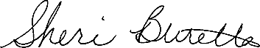

Sheri Buretta

Chairman of the Board | Interim CEO Chugach Alaska Corporation

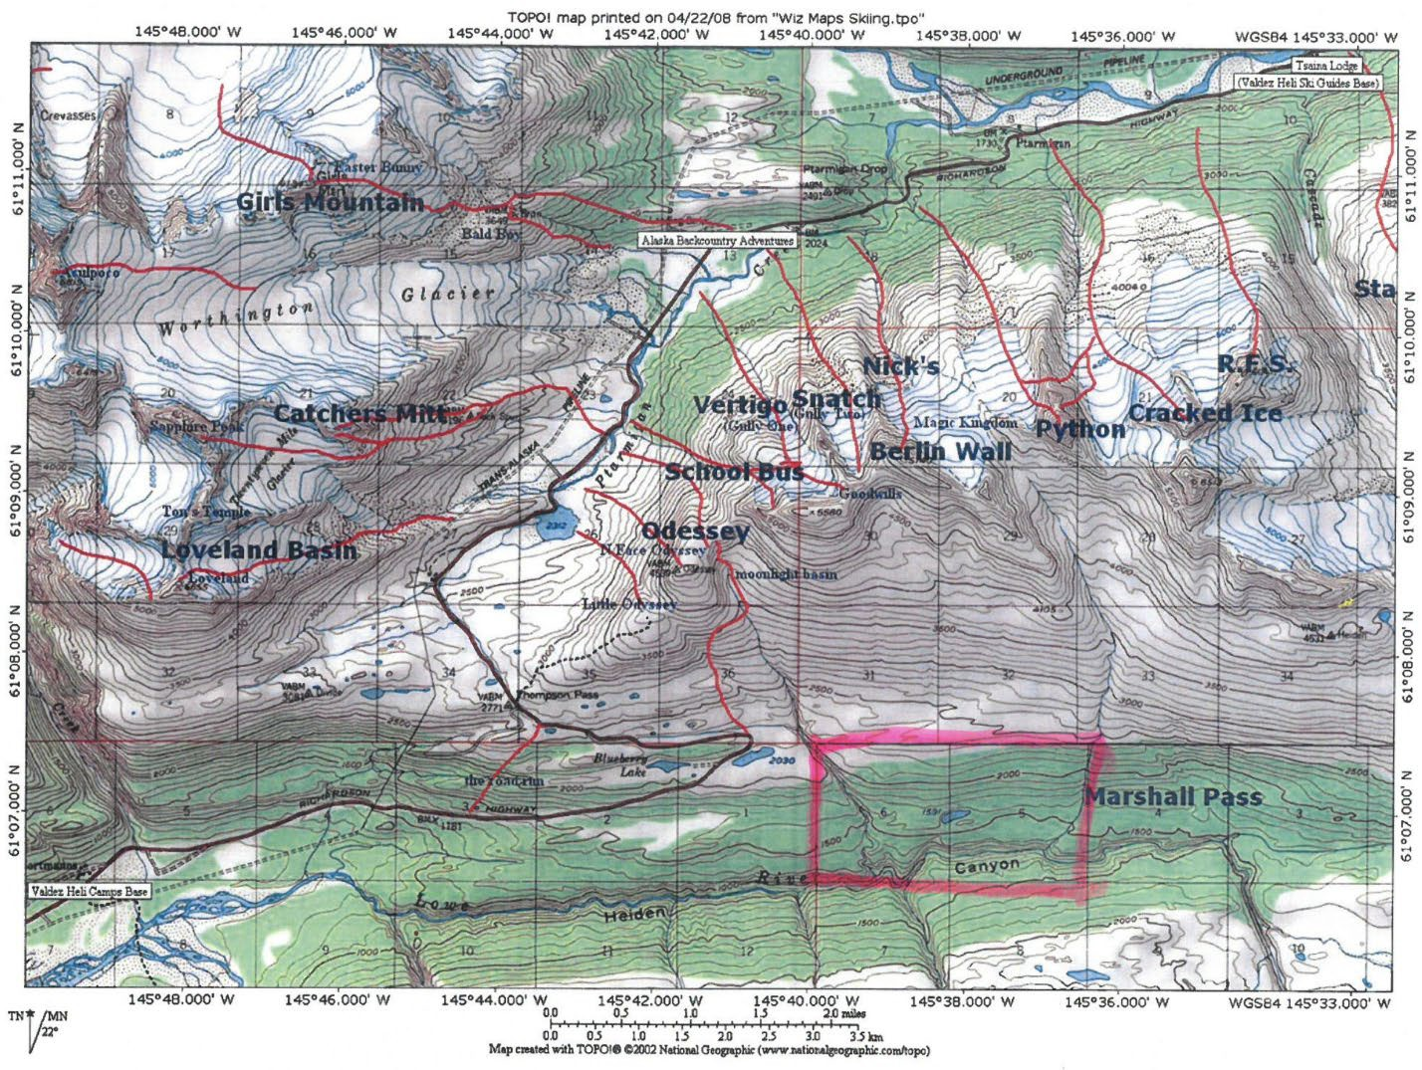

*Map depicting ski trails in Thompson Pass area – highlight shows land exchange area*

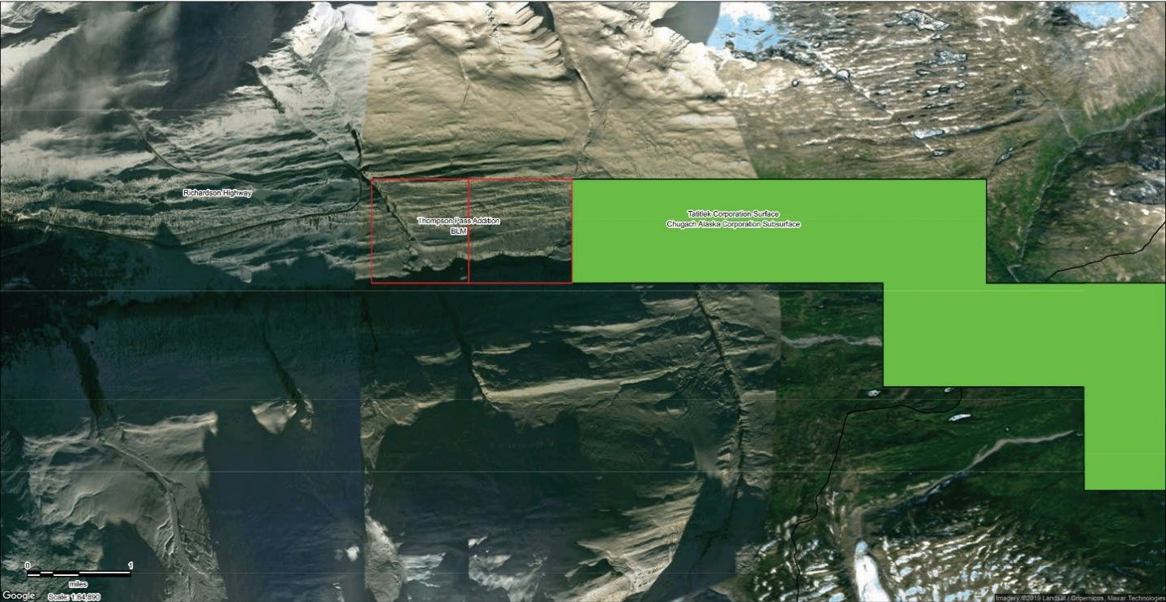

*Satellite map showing land exchange area in relation to lands owned by Chugach and Tatitlek*