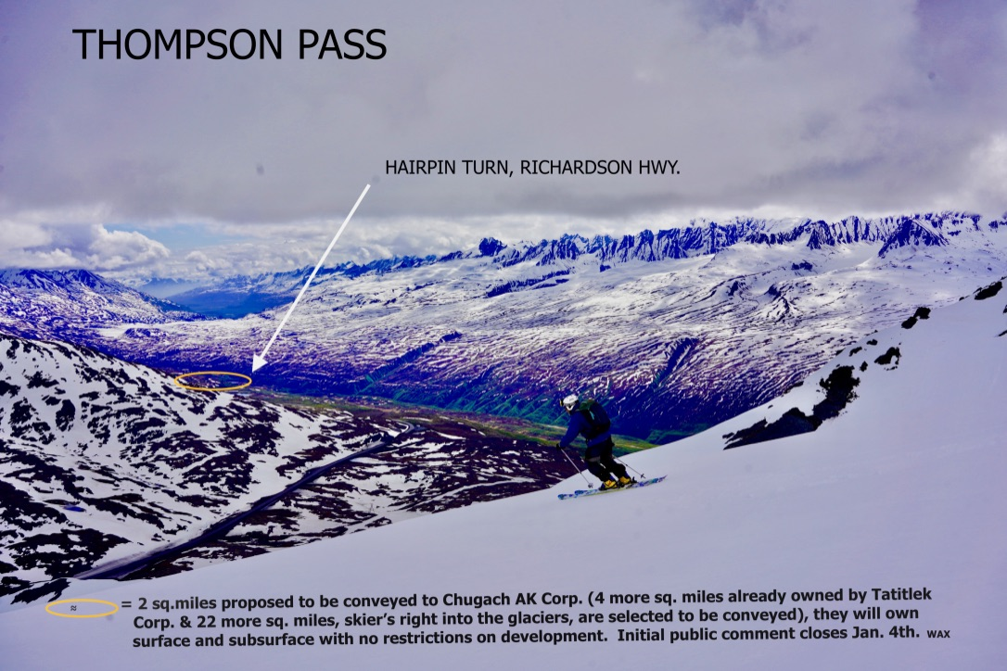

The State of Alaska is poised to give prime public recreation land to private corporations (without public notice or opportunity for comment but BLM is asking for comment ). Senator Lisa Murkowski sponsored the Dingell Act that President Trump signed last year which allows native corporations to undo the settlement of aboriginal land rights. 46 years ago the Alaska Native Settlement Claims Act, ANSCA, allowed the native corporations to select 44 million acres of land and the U.S. then payed them an additional nearly 1 billion dollars as compensation for the rest of the (unselected) land. And now, nearly 50 years later, the 2019 Dingell Act is allowing the native corporations to (change their mind and) exchange that land for what has become the most popular recreation land, including two sections (Sections 5 & 6, Township 9 South, Range 2 West, Copper River Meridian) totaling 2 square miles, roughly 1,260 acres, at the Thompson Pass hairpin turn on the south side of Odyssey mountain (<https://eplanning.blm.gov/public_projects/2003781/200470312/20031510/250037709/EARMP_Amend_ThompsonPassArea_landstatus.pdf>). The sections are attached to both an additional 4 square miles of already native owned land to the east and 22 more square miles of native selected land to the south/southeast, extending out between Bench Glacier and Marshall Glacier including Heiden Glacier and most of the Deserted Glacier (recreationalists know that access to “The Books” is otherworldly but they did not know they it could become history). The conveyance of these 22 square miles simply requires the submittal of a request to BLM for transfer; no public input included. Once an exchange is complete, the corporation is free to do anything (a shopping mall? a nuclear power plant? a mine?) on the land. No environmental will be required (or allowed); and the corporation will own the surface and subsurface rights.

While the state did not reach out for your opinion before submitting a conditional relinquishment (contradicting their guiding doctrine that specifies retention of this land for “recreation”) of these sections, the BLM is reaching out for public input. As the current interim land managers, they are being pressured (by our political appointees) to amend BLM’s East Alaska Resource Management Plan which clearly dictates that these 2 sections are not available. **And you are invited to help guide them through this amendment. Public scoping comments are due on January 4th, 2021** (late comments may be considered due to holiday/covid timing)**.**

**Comment:** [**https://eplanning.blm.gov/eplanning-ui/project/2003781/570/8001860/comment**](https://eplanning.blm.gov/eplanning-ui/project/2003781/570/8001860/comment)

or by mail to: Bureau of Land Management East Alaska RMP Amendment/EA 222 W. 7th Ave., Stop 13 Anchorage, Alaska 99513

**BLM is able to consider alternatives. Let them know if we should allow for exchanges on Thompson Pass. They can retain public ownership and/or easements (or look at entirely other lands) based upon your input. And then in late January or early February BLM will release a draft analysis(based on your public comments) and post (**[**https://eplanning.blm.gov/eplanning-ui/project/2003781/550**](https://eplanning.blm.gov/eplanning-ui/project/2003781/550)**) a 15-day notice prior to a public virtual meeting. There will then be 30 days to comments on BLM’s proposed draft**.

Some folks are disillusioned (muscle memory) that their voice will not matter. While DNR has historically blatantly disregarded public input, the feds have historically been more responsible to the public (BLM just eliminated 475,000 acres of ANWR’s drilling rights based on 40,000 comments largely concerned about subsistence hunting rights relating to caribou, polar bear and bird habitat). So, whatever your opinion, it matters. It is still your land.

The logistics are not simple and the meeting will be just a couple hours. So, I have I attempted to decipher the complexities with the intention of helping folks understand the facts before commenting and/or before the meeting. Perhaps this will allow more time for productive feedback and brainstorming and less time for unravelling how we got here.

Here is the low-down.

How has this seemingly unfathomable proposed land exchange suddenly emerged? Inaccessible land in the Wrangell’s (location is not yet absolute, could be in the Chugach National Forest) is slated to be exchanged for prime road accessible recreation land in Thompson Pass. BLM’s East AK Resource Management Plan, the document that dictates how BLM should manage this land, does not consider it (arguably the most breathtaking accessible AK viewshed) available for private ownership. And neither did I or the many skiers and snowmachiners who have been recreating on these public lands this past week. And yet this discussion is enormously larger than both local recreationalists (see a local’s 12/05/20 photo of the overflowing hairpin parking area at the end of document) and other residents (who may simply be looking for a congestion-free road), a much larger state-wide concern is burrowing.

There are a few primary laws at issue here -The 1959 Alaska Statehood Act, the 1971 Alaska Native Claims Settlement Act (ANCSA) and the 2019 John D. Dingell Jr. Conservation, Management, and Recreation Act. The Alaska Statehood Act allowed the State of Alaska to select nearly 105 million acres of Alaska land (from the U.S.). Then, understandably so, the Alaska natives felt that lands that belonged to them were being given to the State. So in 1971 the United States government settled the question of native ownership of Alaska with ANCSA. ANCSA was a land and cash settlement. The Alaska native corps were allowed to select 44 million acres of land. They were then payed nearly 1 billion dollars as compensation for the rest of the land that they did not select. Most of the ANCSA selections were in place by 1975. Both the State and the ANCSA corporations were allowed to over-select and prioritize, in case some of the lands they selected could not be conveyed to them (due to private in-holdings etc.).

These 2 Thompson Pass hairpin area sections were at one time selected (and then relinquished in 1992) by Tatitlek Corporation. And in 1993 the land became State selected (for “recreation” per the DNR’s guiding doctrine for Thompson Pass, The 1986 Copper River Basin Management Plan). In the meantime (until lands are conveyed), the BLM acts as the interim manager of these and the other ANCSA and State selected lands across Alaska. Over time BLM has conveyed 96% of these entitled selected lands to both the ANCSA corporations and to the State of Alaska. BLM has adjudicated and conveyed (passed title) 99 million acres to the State out of the nearly 105 million acres the State is entitled to; there is a long process involving surveying, appraising etc. before the lands can be conveyed. These Thompson Pass selected parcels are part of the 5.3 million acres yet to be adjudicated (because the State has not requested title). And actually, the State recently (quietly) conditionally retracted their selection (to accommodate the Chugach AK Corp.). Essentially this land still belongs to 300 million Americans. So how then is our public land suddenly becoming privately owned by a native corporation 46 years after the public thought these matters were resolved?

The Dingell Act is the reason. If you look it up online, you will see that Senator Murkowski sponsored the law. A sliver of the Act basically allows Chugach AK Corp. to give back lands it received title to under ANCSA and get different lands – through an exchange. It means that even though lands were not selected by a corporation, they can still get title to them through an exchange. We all realize that Alaska Native Corporations should get the land they were promised in ANCSA, but these lands in Thompson Pass were never promised to Chugach AK Corporation. The corps are now “selecting” the highest public use land (land that was not necessarily originally available to them) to essentially renegotiate ANCSA. And our elected officials and political appointees (Don Young, Dan Sullivan and Lisa Murkowski) are supporting this new land give-away process. In the midst of a widespread mental health crisis our representatives are giving our healing grounds to private corporations.

So why did Senator Murkowski sponsor the Dingell Act? Per ANCSA, BLM was directed to convey surface rights to the village corps and subsurface rights to the regional corps. After the Exxon Valdez oil spill (EVOS), the Exxon settlement funds were set up through a trustee council that looked at purchasing lands from **willing** landowners for habitat restoration. EVOS money was used to purchase (for far above fair market value) the ANCSA surface estate lands from corporations like Tatitlek and Eyak in the Chugach area (go to the EVOS website to find out more). But since the EVOS lands were targeted for restoration a check and balance system was set-up. One entity would own the title to the surface estate while another would own the easement thereby preventing development. In some Chugach area cases, the village corporation sold their surface estate to the Federal land manager, that is, either the Forest Service, the National Park Service or Fish and Wildlife. When a Federal agency holds title to the surface estate under an EVOS acquisition, the State of Alaska holds the conservation easement. That is the check and balance system.

But we are talking about land the village corporations owned, so what does this have to do with Chugach AK Corporation? ANCSA tells the BLM to convey title of the surface estate to the village corporation and the subsurface estate to the regional corporation, like Chugach AK Corp. When the Feds and the State made these EVOS acquisitions they bought only the surface estate, not the subsurface estate. Even though Chugach AK Corp. **could have** been paid for their subsurface estate, they **would not sell** their land. Chugach AK Corp. still owns the subsurface estate and they have argued that they have been harmed by these sales (that they willingly entered for habitat restoration) and cannot develop their subsurface estate so they want to give it all back to the United States – up to 240,000 acres - and get new lands.

In comes the 2019 Murkowski sponsored Dingell Act. Not only does the Act require the BLM to study how the EVOS acquisitions have impacted Chugach AK Corp. but BLM is also obligated to make lands available for exchange and to recommend a land exchange (it’s unclear how an exchange can be considered before the study is completed). Which sounds fine, except that it is allowing the corps to target prime recreation property. And unlike when BLM conveys lands to the State and we all get to continue using them, once the lands are conveyed to an ANCSA corporation they become private lands and only their shareholders can use the lands.

In short of Congress reversing the Dingell Act (not happening), one way to intercept the BLM from conveying the land to the Chugach AK Corp. would be for the State to undo it’s recent relinquishment and ask BLM to give the State title (or patent, that is what the Federal government calls a deed) to prevent the 2 sections from going into private ownership (thereby allowing the State to maintain its’ reputation for reckless land management in the Thompson Pass corridor). But the State could still pass the land off into private hands (the 2 closest private DNR leases are both 100% out of compliance; to the south there are several structures on State land with no existing lease and to the north there is a continuing lease with no payments, insurance, etc.). This temporary fix is not a likely scenario anyway since Don Young, Dan Sullivan and Lisa Murkowski are supporting DNR and the Chugach AK Corp. in allowing for this hand-off of our public playground into a private corporation’s hands; thereby acting inconsistently with the State’s own guiding doctrine, the Copper River Basin Area Management Plan (CRBAMP), which states “The management unit (Unit 15: Thompson Pass) should be retained in state ownership . . . with an emphasis on expanding recreation opportunities (3-103)”. Thompson Pass was one of three areas “recommended for legislative designation (for) hav(ing)e very high recreation value and receiv(ing)e the most public use (A-5).” “The potential for conflict between minerals and other resources is high in these areas. The relative values of fish habitat or recreation are higher than potential mineral values and therefore warrant a closure (A-4).” “Due to land conveyances under the ANSCA and state land disposals, the primary trail issue is to retain and designate existing access to state land (A-6).” “The entire area has spectacular alpine scenery (3-103).”

Furthermore Section 910 of ANILCA prevents the Federal agencies, like BLM, from doing any environmental reviews under the National Environmental Protection Act (NEPA) on anything that leads to conveyances of land, including exchanges, with any ANCSA corporation. They cannot look at the effect on the environment but they can and should look at the effect on the public and our use of our public lands. Chugach Corp. will be able to do anything they want on the property once it is conveyed. Wal-Mart and oil drilling included. A mining operation? A heli-ski lodge/ski resort (unlikely with the warming snowpack/climate and lack of economic viability)? A Princess lodge? A road to Cordova? A nuclear power plant? A local reported speaking with surveyors this fall at the hairpin turn who were exploring logging potential. **Bottom line, anything is possible. There will be no restrictions**. And yes, Tatitlek Corp. does already own 4 sections of attached land to the east (Tatitlek Corp. owns the surface estate and Chugach Corp. owns the subsurface estate). The total private native held land mass (six one square mile sections) would equal 1 mile by 6 miles including both surface and subsurface rights. And there is an additional attached 22 square mile of already selected native corporation land to the south and southeast. Another hidden consideration - once private ownership is secured it is easy to acquire a lease to attached State land.

David Phillips, the lands contact, at Chugach AK Corp. was amiable and generous with his time. He understandably emphasized the preliminary status (noting the State’s relinquishment was conditional). He assured me that they are good neighbors. I reached out to David because it would be much easier to have a stance if I knew what I was standing for. For example, I would be a proponent of mental wellness programs for native youth and adolescents or family camps. But my understanding was that economic viability will take precedence. It’s the mystery of what could happen to the exact land, the “unsurpassed beauty” - Sir Edmond Hillary, where I lived in a snow cave 31 years ago that is disconcerting.

I suppose “anything” could be good and could be bad. It’s up to you to decide. I’m ambivalent because I don’t know what is hiding behind the mountain and I am not impressed by how the trail was broke. But I have shared the facts that I do know.

Some of my personal concerns include – recreational/hunting access (not just winter but these sections also offer great summer access above the vegetation); road safety (28 daily oil tankers, trucks hauling barge containers northbound to the military bases, etc. on an already accident-prone hairpin turn); economic hit (will it destroy or enhance tourism?); suffocation of mental and physical wellness (the south side of Odyssey is the most used ski area in the corridor because of wind protection, accessibility to all ability levels, no crevassed terrain etc., and logging/mining truck traffic could prevent folks from taking the initiative to get out ptarmigan hunting, fishing, berry picking or hiking similar to what occurred during this last year’s road construction; parking availability; noise, light and air pollution; the wellbeing of the nesting trumpeter swans in the lake that crosses between the 2 sections; and (since the land goes down to the Lowe River) exposure for the fish(salmon and dolly varden) and river otters (in fact, with the exception of polar bears, I have seen nearly every AK animal on these lands), the Heiden View residents, the city of Valdez and Prince William Sound to any potential toxic run-off.

I will continue dedicating time to both (re)constructing and maintaining historic trails in the area. And therefore hope (at the very least) the public is able to retain access to the 2 historic trails which bisect the lands in question - RST 1359, the Keystone Canyon-Thompson Pass Trail, and RST 404, the Tasnuna Route. Additionally, I support the State’s request (per the conditional relinquishment) to retain access to the Lowe River. The land also includes a prime snowmachine access route but the precise trail varies with snow/wind conditions seasonally. I am also concerned how development could affect usage of the the recently cleared nearby 1899 Pack Trail (with a new parking area as of the fall of 2020).

(In my opinion) the politics of the current administration are forcing the feds to protect the native corps. against the letter of the law. Highfalutin attorneys and for-profit corporations will always be able to manipulate “letter”s to hear the words they seek (like “profit” perhaps). But BLM is an agency that works for the public, *all* of the public, not just ANCSA corporations. Therefore we should have a say *if* lands are going to be exchanged with an ANCSA corporation, *which* lands are exchanged and *what* access rights we, as the public landowners, should be able to keep. It is our job to let elected officials, political appointees and the BLM know what our rights, interests and concerns are.

Turnigan Pass, Hatcher Pass and really any public land enthusiasts need to take note (and send a note to your representatives!). Become involved with the process. This Dingell Act is just beginning to show its face, help set the precedent.

[**https://eplanning.blm.gov/eplanning-ui/project/2003781/570/8001860/comment**](https://eplanning.blm.gov/eplanning-ui/project/2003781/570/8001860/comment)

[**murkowski**.senate.gov](https://www.murkowski.senate.gov/) [**sullivan**.senate.gov](https://www.sullivan.senate.gov/) [donyoung.house.gov](https://donyoung.house.gov/)

If you would like to further understand the facts, I encourage you to research the following documents – <https://eplanning.blm.gov/eplanning-ui/project/2003781/510>; the 1959 Statehood Act; the 1971 Alaska Native Claims Settlement Act (ANCSA); the 1980 AK National Interest Conservation Land Act (ANILCA); the 1976 Federal Land Policy Management Act (FLPMA – BLM’s Organic Act); the 2007 BLM East AK Resource Management Plan; Section 1113 of the John D. Dingell Jr. Conservation, Management, and Recreation Act; as well as the Exxon Valdez Oil Spill Trustee Council website at: [Home - Exxon Valdez Oil Spill Trustee Council (state.ak.us)](https://evostc.state.ak.us/)

THANKS FOR YOUR TIME!!

Lisa Wax ☺

p.s. My apologies for the holiday/tight timing but I just got wind of this situation last week. And it has taken an enormous effort to make sense of the nonsensical facts.

p.p.s. I tore this from a Newsweek magazine lying around the Seattle airport years ago (so the numbers are likely exponentially higher now), “Since 1993, 1.3 million sq. mi. of wilderness -10% of what’s left on earth- has disappeared, mostly plundered by lumbering, or oil and gas exploration. Scientists found that in less than a century, there could be no wilderness left -nowhere for untouched evolution or natural carbon storage, or human escape.” -Nate Hopper

A local’s 12/05/20 photo (referenced on pg.2) of the overflowing Thompson Pass hairpin turn parking area:

